GIVELIFE- ORGAN REGISTRY PORTAL
A Project Report Submitted in the partial fulfillment of the requirements for the award of the degree of

BACHELOR OF TECHNOLOGY
In

DEPARTMENT OF COMPUTER SCIENCE ENGINNERING
By

P. BHAVANA MANASWINI 2520030154
CH. KAVYA SREE 2520030413

Under the Esteemed Guidance of

Dr. DHULIPALLA RAMYA KRISHNA
Assistant Professor
Department of Computer Science and Engineering




K L (Deemed to be) University DEPARTMENT OF COMPUTER SCIENCE ENGINEERING



Declaration

The Project Report entitled “GIVELIFE-ORGAN RE PORTOL” is a record of Bonafide work of P. BHAVANA MANASWINI - 2520030154 , CH. KAVYA SREE- 2520030413 submitted in partial fulfillment for the award of B. Tech in Computer Science and Engineering to the KL University. The results embodied in this report have not been copied from any other departments/University/Institute.

P. BHAVANA MANASWINI – 2520030154

CH. KAVYA SREE - 2520030413

K L (Deemed to be) University

DEPARTMENT OF COMPUTER SCIENCE ENGINEERING



CERTIFICATE

This is certify that the mini project based report entitled “GIVELIFE-ORGAN RESPIRATORY PORTOL” is a bonafide work done and submitted by BHAVANA MANASWINI - 2520030154, KAVYA SREE – in partial fulfillment of the requirements for the award of the degree of BACHELOR OF TECHNOLOGY in Department of Computer Science Engineering, K L (Deemed to be University), during the academic year 2025-2026.

Signature of the Guide

Signature of the Course Coordinator Signature of the HOD

ACKNOWLEDGEMENT
The success in this project would not have been possible but for the timely help and guidance rendered by many people. Our wish to express my sincere thanks to all those who has assisted us in one way or the other for the completion of my project.

Our greatest appreciation to my Course Coordinator Dr K. Madhavi , and my guide Dr D. Ramya Krishna , Department of Computer Science which cannot be expressed in words for his/her tremendous support, encouragement and guidance for this project.

We express our gratitude to Dr. K . Chaitanya Kumar(CSE), Head of the Department for Computer Science Engineering for providing us with adequate facilities, ways and means by which we are able to complete this project-based Lab.

We thank all the members of teaching and non-teaching staff members, and also who have assisted me directly or indirectly for successful completion of this project. Finally, I sincerely thank my parents, friends and classmates for their kind help and cooperation during my work.

P.BHAVANA MANASWINI – 2520030154 CH. KAVYA SREE – 2520030413

Abstract

The GiveLife — Organ Donor Registry Portal is a web-based application developed to simplify the process of organ donor registration and basic donor-recipient matching. The main aim of this project is to create an easy-to-use platform where individuals can register as organ donors, provide their consent, and view relevant donor information in a clear and organized manner.

This application is built using HTML, CSS, and JavaScript, focusing on creating a clean, interactive, and user-friendly interface. To keep the system simple and suitable for learning purposes, browser LocalStorage is used to store and manage user data instead of using a database. This approach allows the application to function smoothly without requiring complex backend technologies.

The system includes key features such as a donor registration form, a consent form where users officially agree to donate their organs, a donor list display, and a basic matching system. The matching process is implemented using JavaScript by comparing important details such as blood group and organ type. The application also provides simple status tracking, indicating whether a donor is available or matched.

The output of the system is generated dynamically based on user input. When users enter their details, the data is stored in LocalStorage and immediately reflected on the interface. Matching results and updates are displayed instantly, making the application responsive and interactive.

Overall, this project demonstrates how simple web technologies can be used to address real-world problems effectively. It highlights fundamental concepts of web development while maintaining clarity, simplicity, and practical usability.

Index

S.  No. | Chapters | Topics | Page.no
 |  | Acknowledgement
 |  | Abstract
1 | Introduction | - Background of the project  - Problem statement  - Scope of the project  - Objective(s)  - Importance of the application  - Target users/audience | 5-15
2 | System Requirements | - Hardware requirements  - Software requirements  - Development tools and frameworks | 16-21
3 | Technology Stack | - Front-end (e.g., React.js, Angular, HTML/CSS)  - Back-end (e.g., Node.js, Django, Spring Boot)  - Database (e.g., MongoDB, MySQL, PostgreSQL)  - Version Control (e.g., Git, GitHub)  - APIs or External services (e.g., Firebase, Stripe) | 22-32
4 | System Architecture | - High-level architecture diagram  - Description of each layer (frontend, backend, database)  - Deployment architecture (e.g., cloud, local, CI/CD  pipelines) | 33-36
5 | Design | 5.2 ER Diagram / Database schema | 37
6 | Implementation | - Module-wise implementation  - Front-end logic (UI rendering, state management)  - API integration  - Authentication & Authorization | 38-47
7 | Features | - List of main features  - How each feature works (user perspective + technical description) | 48-55
8 | Testing | - Postman testing (frontend/backend)  - Integration testing  - Tools used for testing  - Test cases and results | 56-64
9 | Deployment | - Steps to deploy  - Environment configuration  - Hosting of frontend and backend | 65-73
10 | Challenges & Limitations | - Issues faced during development  - Solutions applied  - Current limitations or known bugs | 74-82
11 | Future Enhancements | - Planned features  - Possible integrations or optimizations | 83-88
12 | Conclusion | - Summary of the project  - What was achieved  - Skills learned during development | 89-97
13 | References | - Books, tutorials, APIs, documentation sites used | 98-99

14 | Appendices | - Screenshots of the app  - Sample code snippets  - Installation/setup instructions  - User manual or guide  -Geo Tag photos with guide  -Review forms with guide signatures | 100-105

CHAPTER -1 INTRODUCTION

1.1 Background of the Project

Organ donation is one of the most profound and life-saving contributions an individual can make to humanity. A single organ donor has the potential to save up to eight lives and improve the quality of life for many more through tissue donation. Despite this incredible potential, the global demand for transplantable organs far exceeds the available supply, creating a critical gap that costs thousands of lives every year.

In India alone, approximately 1.8 lakh patients require kidney transplants annually, while only around 10,000 transplants are actually performed. Similar shortfalls exist for liver, heart, lung, cornea, and pancreas donations. This staggering disparity is not merely a medical problem — it is a systemic and organizational one.

The organ donation ecosystem in its current state is plagued by several deep-rooted challenges. First, there is a significant lack of public awareness about how, where, and why to register as an organ donor. Many willing individuals never complete the registration process simply because the system is inaccessible, paper-heavy, or unclear.

Second, existing hospital-level donor registries are fragmented and isolated — there is no unified national or regional digital platform that connects donors, recipients, hospitals, and transplant coordinators in real time. Third, the process of matching a donor to a compatible recipient is highly complex, involving blood group compatibility, organ type, geographic proximity, urgency of need, and medical history — all of which are currently managed manually in most institutions, leading to delays, errors, and missed opportunities.

Fourth, consent management remains a major hurdle. Many families of deceased donors are unaware of their loved one's donation intent due to the absence of a reliable digital consent record. Finally, post-transplant coordination and outcome tracking are rarely systematized, making it difficult to measure success rates or improve workflows over time.

It is within this context that the GiveLife Registry System was conceived and developed. The project is a comprehensive, web-based organ donation registry and transplant coordination platform designed to digitize and streamline the entire organ donation lifecycle. The system serves multiple stakeholders simultaneously — donors who wish to register their intent and manage consent, recipients and their medical teams who need visibility into waitlist status and match progress, hospital administrators who coordinate between surgical teams and donor families, and system-level administrators who require analytics and reporting to make data-driven decisions.

The OrganLink Registry System was built using modern web technologies to ensure scalability, usability, and reliability. The frontend is developed using React.js, one of the most widely adopted JavaScript libraries for building dynamic, component-based user interfaces. State management across the application is handled using Context API combined with useReducer, implementing a global store pattern that ensures all modules share a single source of truth.

Navigation between modules is managed through React Router, enabling a seamless single-page application experience. The application integrates LocalStorage for client-side data persistence, ensuring that donor and recipient records are retained across browser sessions without requiring a backend connection during development.

The user interface is styled using Tailwind CSS combined with custom CSS3 animations and transitions, delivering a clean, responsive, and professional medical-grade design. The project is also structured in a way that it can be easily connected to a real backend using Node.js, Express.js, and MySQL in the future when needed.

The system is organized into ten fully functional modules — a real-time Dashboard, Donor Registration, Recipient Waitlist Management, Intelligent Donor-Recipient Matching, Transplant Coordination and Workflow Tracking, Consent Management, Hospital and Doctor Directory, Notification System, Dark Mode interface, and an Analytics and Reporting Dashboard. Each module is designed to address a specific pain point in the existing organ donation process, together forming an end-to-end solution that is both practically useful and technically sophisticated.

The Hospital and Doctor Directory module deserves special mention as it directly addresses one of the most overlooked gaps in donor awareness. Donors often want to contribute but do not know which hospital to approach, which doctor specializes in transplant surgery, or what the registration process at a facility looks like. By embedding accredited hospital listings, specialist doctor profiles, contact information, supported organ types, and operational timings directly into the platform, the system empowers donors with the information they need to act on their intent immediately and confidently.

In summary, the OrganLink Registry System represents a significant step forward in modernizing organ donation management in India. By combining a user-friendly interface with robust data management, intelligent matching, and comprehensive coordination tools, the project demonstrates how technology can be leveraged to save lives — transforming a fragmented, manual, and awareness-poor system into a unified, digital, and data-driven platform that gives every patient on a waiting list a better chance at survival.

1.2 Problem Statement

In today's world, organ donation is one of the most important and life-saving acts a person can do. Every year, thousands of patients across India are waiting for an organ transplant to survive. However, the number of actual transplants that happen is very low compared to the number of patients who need them. The main reason for this is not that people are unwilling to donate — it is because there is no proper system in place to manage the entire process efficiently.

Currently, most organ donation processes are handled manually through paperwork and phone calls between hospitals. There is no single digital platform where a donor can simply register their details, select the organs they wish to donate, and give their consent online. Because of this, many willing donors never complete the registration process and their intent goes unrecorded.

On the recipient side, patients who are waiting for an organ transplant have no way to check their waitlist status or know when a matching donor becomes available. Their families are left in the dark, with no updates or transparency about the process. This causes unnecessary stress and delays in critical medical situations.

Another major problem is the matching process. Matching a donor to the right recipient is a complex task. It depends on multiple factors such as blood group compatibility, the type of organ needed, the location of both the donor and the recipient, and the urgency of the patient's condition. In most hospitals today, this matching is done manually by coordinators, which takes a lot of time and increases the chances of human error. A wrong match or a delayed match can cost a patient their life.

Consent management is also a serious issue. Many families of deceased donors are unaware that their loved one had agreed to donate organs because there was no proper digital record of that consent. Without a verified consent record, hospitals cannot proceed with the donation even if the donor had expressed their wish to donate.

Furthermore, there is a lack of information available to donors about which hospitals are registered for organ transplants, which doctors specialize in transplant surgery, and what the exact process is for donating an organ. This lack of awareness stops many people from taking the first step.

Finally, there is no system to track what happens after a transplant is scheduled. Whether the transplant was completed successfully, which hospital it was performed in, and what the overall success rate is — none of this information is recorded or made available in a structured way.

All of these problems together create a broken and inefficient system that costs lives every day. There is a clear and urgent need for a centralized, digital, and easy-to-use platform that brings donors, recipients, hospitals, and coordinators together in one place — making the entire organ donation process faster, transparent, and more effective. The GiveLife Registry System is built exactly to solve these problems.

1.3 Scope of the Project

The Organ Registry System is designed with a wide and meaningful scope that touches every part of the organ donation process — from the moment a donor decides to register, all the way to the successful completion of a transplant. The scope of this project covers both the current features that have been implemented and the future possibilities that the system can grow into.

1. Donor Registration and Management
The most fundamental scope of this project is to provide every willing organ donor in the country with a simple, accessible, and digital way to register themselves. The system allows any individual to enter their personal details such as name, age, blood group, city, and the organs they wish to donate. They can also give or revoke their consent at any point in time. This creates a verified and reliable digital record of every donor's intent, which can be accessed instantly by hospitals and coordinators when needed. The scope extends to managing hundreds and thousands of donor records efficiently with search and filter capabilities.

2. Recipient Waitlist Management
The project covers the complete management of patients who are waiting for organ transplants. Every recipient is recorded with their medical details including the organ they need, their blood group, urgency level, and how long they have been waiting. The system prioritizes patients based on their urgency — from Critical to Low — ensuring that the most serious cases are attended to first. This brings much-needed transparency and structure to a process that is currently handled informally in most hospitals.

3. Intelligent Donor-Recipient Matching
One of the most important scopes of this project is the automated matching system. Instead of relying on manual coordination, the system automatically calculates a compatibility score between a donor and a recipient based on blood group match, organ type, and geographic proximity. This significantly reduces the time taken to find a suitable donor for a waiting patient. In the future, this matching algorithm can be extended to include more advanced medical parameters such as tissue typing, age compatibility, and medical history, making it even more accurate and reliable.

4. Transplant Coordination and Workflow Tracking
The project also covers the end-to-end tracking of every transplant procedure. From the moment a match is initiated to the scheduling of the surgery and the final completion of the transplant, every step is recorded and visible in the system. Hospital names, surgery dates, donor and recipient details, and the current status of each transplant are all maintained in one place. This gives coordinators full visibility into the transplant pipeline and helps avoid delays or missed procedures.

5. Consent Management
Managing donor consent is a critical part of organ donation that is often overlooked. The scope of this project includes a dedicated consent management module where the consent status of every donor is clearly recorded and can be updated at any time. This ensures that hospitals and coordinators always have verified consent before proceeding with any donation, avoiding legal and ethical complications.

6. Hospital and Doctor Directory
The project extends its scope to include a comprehensive directory of accredited hospitals and specialist doctors. This is particularly important for donors who want to know where to go and who to contact. The directory includes hospital addresses, contact numbers, supported organ types, operational timings, and the names and specializations of transplant doctors. This bridges the awareness gap that prevents many willing donors from taking action.

7. Analytics and Reporting
The analytics module broadens the scope of the project beyond individual transactions to a system-wide view. Administrators and healthcare policymakers can use the analytics dashboard to monitor organ supply versus demand, blood group distribution, transplant success rates, and geographic coverage of the donor registry. These insights can drive better decision-making, targeted awareness campaigns, and efficient resource allocation across hospitals.

8. Future Scope
Looking ahead, the system can be expanded to include mobile application support, real-time notifications via SMS and email, integration with government health databases like NOTTO (National Organ and Tissue Transplant Organisation), live video consultation with transplant doctors, and AI-based urgency prediction for recipients. With a proper backend and MySQL database, the system can scale to serve an entire state or country.

In conclusion, the GiveLife Registry System has a broad, meaningful, and expandable scope that addresses a genuine healthcare crisis. It is not just a college project — it is a foundation for a real-world solution that can make organ donation simpler, faster, and more accessible for everyone involved.

.1.4 Objectives of the Project
The primary aim of the GiveLife Registry Portal is to create a centralized, digital, and efficient platform that simplifies and modernizes the entire organ donation and transplant coordination process. The project has been developed with a set of clear and well-defined objectives that guide every module and feature of the system. Each objective directly addresses a real-world problem that exists in the current organ donation ecosystem in India and aims to provide a practical, meaningful, and technology-driven solution that can genuinely make a difference in people's lives.

1. To Provide a Simple and Accessible Donor Registration Platform
One of the most important objectives of this project is to make organ donor registration as simple and accessible as possible. The system provides a clean and easy-to-use registration form where any willing individual can enter their personal details such as name, age, blood group, city, and the organs they wish to donate. The goal is to remove all barriers that currently prevent willing donors from completing their registration and to ensure that every donor's intent is recorded digitally and securely for future use. The system also allows donors to update their details or change their organ preferences at any point in time.

2. To Maintain a Transparent and Organized Recipient Waitlist
The project aims to bring full transparency and organization to the recipient waitlist management process. Every patient who needs an organ transplant is recorded in the system with their complete medical details including the organ required, blood group, urgency level, and the duration of their wait. The objective is to ensure that the most critical patients are always prioritized and that their families have clear visibility into their waitlist status at all times, reducing unnecessary stress and confusion during an already difficult period in their lives.

3. To Automate the Donor-Recipient Matching Process
A core objective of this project is to replace the slow and error-prone manual matching process with an automated and intelligent compatibility system. The matching module calculates a compatibility score for every potential donor-recipient pair based on blood group match, organ type, and geographic proximity. The objective is to significantly reduce the time taken to find a suitable donor for a waiting patient and to minimize the risk of human error in one of the most critical and time-sensitive steps of the entire transplant process.

4. To Track the Complete Transplant Workflow
The project aims to provide end-to-end visibility into every transplant procedure from the moment a match is initiated to the final completion of the surgery. Every transplant record includes the donor name, recipient name, organ type, hospital name, scheduled date, and current status. The objective is to give transplant coordinators and hospital administrators a complete and real-time view of the entire transplant pipeline so that no procedure is ever delayed, missed, overlooked, or left untracked due to poor communication or lack of records.

5. To Manage and Verify Donor Consent Digitally
One of the key objectives of this project is to create a reliable and easily accessible digital record of every donor's consent. The consent management module allows coordinators to grant or revoke consent for any donor at any time and ensures that hospitals always have verified authorization before proceeding with a donation. This objective directly addresses the legal and ethical complications that arise when consent records are missing, outdated, or unverified in critical medical situations.

6. To Provide a Hospital and Doctor Directory for Donor Awareness
The project aims to bridge the awareness gap that stops many willing donors from taking action by providing a comprehensive directory of accredited hospitals and specialist transplant doctors. The objective is to ensure that every donor knows exactly which hospital to visit, which doctor to consult, what organs that hospital supports, and what the contact details and operational timings are. This information empowers donors to act on their intent immediately and confidently without any confusion, delay, or need to search elsewhere for guidance.

7. To Deliver Real-Time Analytics for Better Decision Making
The project aims to provide healthcare administrators and policymakers with meaningful data insights through a dedicated analytics dashboard. The objective is to give decision-makers a clear and visual view of organ supply versus demand, blood group distribution among donors, transplant success rates, and geographic coverage of the registry. These insights can be used to plan targeted awareness campaigns, identify critical organ shortages in specific regions, and allocate hospital resources more effectively and efficiently across the country.

8. To Build a Scalable and Future-Ready System
The final and overarching objective of this project is to build a system that is not just functional today but is also ready to grow and scale in the future. The application is structured in a way that it can be easily connected to a real backend server using Node.js and Express.js, integrated with a MySQL database for permanent and secure data storage, and extended with features like mobile application support, SMS and email notifications, and government health database integration such as NOTTO. The objective is to ensure that the GiveLife Registry Portal can evolve from a college project into a real-world solution that makes a genuine and lasting difference in saving lives across India.

1.5 Importance of the Application

The GiveLife Registry Portal is an innovative healthcare application developed to support and improve the organ donation and transplantation process. Organ donation is one of the most significant contributions a person can make to society because it has the power to save and transform multiple lives. However, the shortage of registered organ donors and the challenges involved in managing donor and recipient information often create delays in transplantation procedures. The GiveLife Registry Portal addresses these issues by providing a secure, efficient, and centralized digital platform that connects donors, recipients, hospitals, transplant centers, and healthcare authorities. This system plays a vital role in improving healthcare services and increasing the effectiveness of organ donation programs.

One of the major importance of the GiveLife Registry Portal is its ability to create a centralized and organized database of organ donors and recipients. In traditional systems, donor information may be maintained separately by different hospitals or organizations, making coordination difficult and time-consuming. The GiveLife Registry Portal brings all donor and recipient information together into a single platform. This centralized approach allows healthcare professionals to access accurate and updated information quickly. By maintaining detailed records such as blood group, age, medical history, organ availability, and recipient requirements, the system helps improve the efficiency of organ allocation and transplantation.

Another significant benefit of the portal is its role in saving lives through faster organ matching and allocation. Many patients suffering from severe kidney disease, liver failure, heart disorders, lung diseases, and other critical health conditions depend on organ transplantation for survival. In emergency situations, every minute is valuable. The GiveLife Registry Portal uses digital technology to identify suitable matches between donors and recipients more quickly than manual methods. By reducing delays in communication and data processing, the application helps ensure that available organs reach eligible recipients in the shortest possible time. Faster matching not only increases survival rates but also improves the success of transplantation procedures.

The portal also plays a critical role in reducing administrative workload and paperwork. Traditional organ donation systems often involve large amounts of manual documentation, which can lead to errors, duplication of records, and delays in processing applications. The GiveLife Registry Portal automates many of these tasks, including donor registration, recipient registration, application verification, data updates, and report generation. Automation reduces the burden on healthcare staff and allows them to focus more on patient care. It also improves the accuracy and reliability of information stored within the system.

One of the most important objectives of the GiveLife Registry Portal is to increase public awareness about organ donation. Many people are willing to donate organs but lack proper knowledge about the process, eligibility requirements, and benefits of becoming a donor. The portal can provide educational resources, awareness campaigns, frequently asked questions, success stories, and guidelines related to organ donation. These features help educate the public and encourage more individuals to register as donors. As the number of registered donors increases, more organs become available for transplantation, ultimately helping a larger number of patients in need.

The application also contributes significantly to building trust and transparency in the organ donation system. Public confidence is essential for the success of organ donation programs. People often have concerns about fairness, ethical practices, and the proper use of donated organs. The GiveLife Registry Portal maintains complete records of donor registrations, recipient requests, organ allocation decisions, and transplantation activities. This transparency ensures that organs are allocated according to medical necessity, compatibility, and legal regulations rather than personal influence or unfair practices. Transparent operations help strengthen public trust and encourage greater participation in donation programs.

Another key importance of the portal is its ability to enhance communication and coordination among healthcare stakeholders. Organ transplantation requires collaboration between multiple hospitals, transplant centers, laboratories, doctors, and government authorities. Without an effective communication system, delays can occur, reducing the chances of successful transplantation. The GiveLife Registry Portal acts as a common platform where authorized users can share information, verify donor details, update patient records, and coordinate transplant procedures in real time. Improved communication leads to better decision-making and more efficient management of transplantation activities.

The GiveLife Registry Portal also provides secure management of sensitive healthcare data. Organ donation involves personal information, medical records, laboratory results, and legal documents that must be protected from unauthorized access. The application can implement advanced security measures such as encrypted databases, secure login systems, role-based access controls, and regular data backups. These security features help ensure confidentiality, integrity, and availability of information. Protecting user data is essential for maintaining trust among donors, recipients, and healthcare organizations.

An additional advantage of the portal is its support for data analysis and healthcare planning. Healthcare authorities and policymakers require accurate data to evaluate the effectiveness of organ donation programs. The GiveLife Registry Portal can generate reports on donor registrations, transplant success rates, organ demand, waiting list statistics, and geographical distribution of donors and recipients. These insights help healthcare organizations identify trends, allocate resources effectively, and develop strategies to improve organ donation awareness and transplantation services. Data-driven decision-making contributes to the overall improvement of healthcare systems.
The portal is also highly beneficial for emergency response and critical patient management. Patients waiting for organ transplants often face life-threatening situations. The ability to quickly access recipient information, verify compatibility, and identify available donors can make a significant difference in emergency cases. Real-time updates and automated notifications ensure that relevant stakeholders are informed immediately when a suitable organ becomes available. This rapid response capability increases the likelihood of successful transplants and reduces the risk of organ wastage.

From a technological perspective, the GiveLife Registry Portal supports the digital transformation of healthcare services. Modern healthcare systems increasingly rely on digital platforms to improve efficiency, accessibility, and quality of care. By replacing manual processes with an online system, the portal enables users to register, update information, track application status, and access resources from any location with internet connectivity. This convenience improves user experience and makes organ donation services more accessible to a wider population.

The application also promotes social responsibility and community welfare. Organ donation is a noble act that can save several lives and improve the quality of life for many patients. The GiveLife Registry Portal encourages individuals to contribute to society by becoming registered donors. Through awareness programs and easy registration processes, the platform helps foster a culture of compassion, generosity, and humanitarian service. It highlights the importance of helping others and demonstrates how technology can be used to create a positive social impact.

Furthermore, the portal ensures compliance with medical, ethical, and legal standards related to organ donation and transplantation. Organ donation is governed by strict regulations to prevent misuse, illegal organ trade, and unethical practices. The GiveLife Registry Portal can incorporate verification procedures, consent management systems, and audit trails to ensure that all activities follow established laws and healthcare guidelines. Compliance with regulations enhances the credibility and reliability of the system.

The GiveLife Registry Portal also plays a crucial role in creating a sustainable and future-ready organ donation ecosystem. By maintaining long-term records of donors, recipients, and transplant outcomes, the system helps medical researchers study trends and improve transplantation techniques. The portal can support future integration with emerging technologies such as Artificial Intelligence (AI), machine learning, and predictive analytics to enhance donor-recipient matching accuracy and reduce waiting times further. It also enables nationwide collaboration among healthcare institutions, ensuring that organs are utilized efficiently and reach patients regardless of geographical barriers. Furthermore, the platform strengthens community engagement by encouraging citizens to participate in life-saving initiatives. Through continuous awareness campaigns, transparent operations, and efficient management, the GiveLife Registry Portal contributes significantly to improving public health, reducing mortality rates, and giving thousands of patients a second chance at life. It represents a meaningful combination of healthcare, technology, and social responsibility dedicated to saving lives and building a healthier future for society.

In conclusion, the GiveLife Registry Portal is a highly valuable healthcare application that addresses many challenges associated with organ donation and transplantation. It centralizes donor and recipient information, improves matching efficiency, reduces waiting times, enhances communication, strengthens data security, increases public awareness, and supports transparent organ allocation. The portal not only streamlines healthcare operations but also contributes to saving lives, promoting social responsibility, and advancing digital healthcare transformation. By connecting donors with patients in need through a reliable and efficient platform, the GiveLife Registry Portal serves as a powerful tool for building a more effective, ethical, and life-saving organ donation ecosystem. Its impact extends beyond technology, creating hope for patients and contributing to a healthier and more compassionate society.

1.6 Target Users / Audience
The GiveLife – Organ Donor Registry Portal is designed to serve multiple stakeholders involved in the organ donation and transplantation process. The system provides a centralized platform that enables efficient donor registration, donor management, consent handling, and donor-recipient matching. The primary target users of the portal are described below.

1. Donors
Individuals who wish to voluntarily donate their organs are the primary users of the system. Donors can register their personal information, blood group details, organ donation preferences, and contact information through the portal. They can also provide consent for organ donation and update their details whenever necessary. The portal makes the registration process simple, transparent, and easily accessible.

2. Healthcare Professionals
Doctors, transplant coordinators, and other healthcare professionals can use the system to search for registered donors and identify compatible donors for recipients. The donor matching module assists medical personnel by providing donor information based on blood group compatibility and organ availability. This helps reduce the time required to locate suitable donors during critical situations.

3. Hospitals and Medical Institutions
Hospitals and transplant centers are important users of the portal. They can utilize the system to access donor records, manage organ donation requests, and coordinate transplantation activities. The centralized database helps healthcare institutions maintain accurate donor information and improve communication during the donation process.

4. System Administrators
Administrators are responsible for managing and maintaining the portal. They can monitor donor registrations, verify records, update donor status, remove invalid entries, and oversee overall system operations. Administrators also ensure that the database remains accurate, secure, and up to date.

5. Organ Donation Organizations
Government agencies, non-governmental organizations (NGOs), and organ donation awareness groups can use the portal to promote organ donation programs and maintain donor records. These organizations can benefit from the statistical information and reporting features available within the system.

6. Researchers and Healthcare Analysts
Researchers studying organ donation trends and healthcare management systems can utilize the portal's data and statistics for educational and analytical purposes. The system can help identify donation patterns, donor demographics, and organ availability trends.

Conclusion
The GiveLife – Organ Donor Registry Portal is designed to benefit a wide range of users including donors, healthcare professionals, hospitals, administrators, organ donation organizations, and researchers. By providing a centralized and efficient platform for organ donor management, the system supports faster donor identification, improved record management, and increased awareness of organ donation initiatives.

CHAPTER -2 SYSTEM REQUIREMENT

Hardware requirements form the foundation of the GiveLife – Organ Donor Registry Portal and define the physical resources necessary for the successful development, testing, deployment, and operation of the system. Since the project is a web-based healthcare platform designed to facilitate organ donor registration, donor management, recipient matching, and awareness creation, the underlying hardware infrastructure must be capable of supporting reliable performance, secure data processing, and continuous accessibility. The hardware requirements can be broadly categorized into development environment requirements and end-user requirements. The development environment requires sufficient computing resources to support coding, testing, debugging, and deployment activities, whereas end users require only standard computing devices to access the portal efficiently.

The development system should ideally be equipped with an Intel Core i5 processor or an equivalent AMD Ryzen 5 processor operating at a minimum clock speed of 2.4 GHz. A multi-core processor is preferred because developers frequently execute multiple applications simultaneously, including source code editors, web browsers, testing tools, and version control systems. During the implementation phase, the processor handles the execution of HTML, CSS, and JavaScript code while also supporting browser rendering and debugging processes. A powerful processor significantly improves productivity by reducing application load times and ensuring smooth multitasking capabilities.

Memory is another critical hardware component required for efficient system development. A minimum of 8 GB RAM is recommended to ensure stable operation of development tools, browser instances, and testing environments. Although the application itself is lightweight, modern development environments consume significant memory resources when multiple browser tabs, code editors, and debugging utilities are active simultaneously. Systems equipped with 16 GB RAM provide an even smoother development experience by allowing efficient execution of concurrent tasks without performance degradation.

Storage plays an essential role in maintaining source code repositories, project documentation, testing files, and deployment packages. The development machine should contain at least 250 GB of available storage space, preferably in the form of a Solid State Drive (SSD). SSD technology offers significantly faster read and write operations compared to conventional hard disk drives, thereby improving system responsiveness and reducing application startup times. Additional storage capacity may also be utilized for maintaining backups, screenshots, reports, and future project enhancements.

A high-resolution display monitor contributes significantly to development efficiency and user interface design. A Full HD monitor with a resolution of 1920 × 1080 pixels is recommended because it allows developers to simultaneously view source code, browser output, debugging consoles, and project documentation. The use of larger displays improves workflow efficiency and facilitates responsive design testing across multiple screen dimensions. Standard input devices such as a keyboard and mouse are required for development activities, while mobile devices may be used for responsive interface testing and validation.

From a deployment perspective, the GiveLife Registry Portal can be hosted on a dedicated server or cloud-based infrastructure. A server equipped with a quad-core processor, 16 GB RAM, and SSD storage is sufficient to support multiple concurrent users accessing the system.
Cloud platforms such as Amazon Web Services (AWS), Google Cloud Platform (GCP), and Microsoft Azure can be utilized to provide scalable infrastructure, high availability, automated backups, and enhanced reliability. These cloud solutions ensure uninterrupted access to the portal and support future expansion as the number of users increases.

The hardware requirements for end users are considerably lower. Donors, recipients, healthcare professionals, and administrators can access the portal using standard desktop computers, laptops, tablets, or smartphones. A dual-core processor, 4 GB RAM, and a modern web browser are sufficient for smooth operation of the application. Since the system follows a responsive design approach, it can adapt effectively to various screen sizes and device configurations. The minimal hardware dependency of the portal increases accessibility and makes it suitable for deployment in hospitals, healthcare centers, NGOs, and rural healthcare facilities where high-end computing resources may not be available.
In conclusion, the hardware requirements of the GiveLife Registry Portal are designed to balance performance, accessibility, and scalability. The system requires moderate hardware resources during development and deployment while maintaining low requirements for end users. This approach ensures broad accessibility and enables efficient implementation of organ donation management services across diverse healthcare environments.

2.2 Software Requirements
Software requirements define the technological environment necessary for designing, developing, testing, deploying, and maintaining the GiveLife – Organ Donor Registry Portal. As a web-based healthcare application, the portal relies on modern web technologies that provide functionality, responsiveness, security, and scalability. The software stack selected for the project emphasizes simplicity, portability, maintainability, and cross-platform compatibility.

The operating system serves as the foundation of the software environment. The development and deployment of the GiveLife Registry Portal can be performed on Windows 10, Windows 11, Ubuntu Linux, or macOS. Windows provides a user-friendly environment and extensive software compatibility, while Linux offers superior stability, security, and open-source flexibility. Ubuntu Linux is particularly advantageous for server deployment due to its efficient resource utilization and strong community support. macOS also provides a reliable development environment, particularly for cross-platform browser testing.

Since the portal is accessed through a web browser, browser compatibility is a critical requirement. The application supports modern browsers including Google Chrome, Mozilla Firefox, Microsoft Edge, and Safari. These browsers provide full support for HTML5, CSS3, and JavaScript technologies used throughout the project. Browser compatibility ensures that users experience consistent functionality regardless of their preferred browsing platform.

The primary technologies utilized in the development of the GiveLife Registry Portal are HTML5, CSS3, and JavaScript. HTML5 serves as the structural framework of the application and defines the layout of forms, navigation menus, information panels, and donor registration interfaces. The semantic features of HTML5 improve accessibility and maintainability while supporting modern web standards.

CSS3 is responsible for the visual presentation and responsive design of the application. Through the use of flexible layouts, media queries, animations, and styling rules, CSS3 ensures that the portal provides a consistent user experience across desktops, tablets, and mobile devices. Responsive design is particularly important because users may access the system from a variety of device types and screen sizes.

JavaScript forms the core of the application's dynamic functionality. It enables client-side validation, donor registration processing, data manipulation, organ matching operations, user notifications, and interactive interface elements. JavaScript improves responsiveness by allowing actions to be performed without repeatedly reloading web pages. The language also supports asynchronous operations, enhancing the efficiency of user interactions and data processing.

The application utilizes browser-based Local Storage for maintaining donor records and application data. Local Storage provides a lightweight data management mechanism that eliminates the need for a complex database management system during the initial implementation phase. Future versions of the portal may incorporate database technologies such as MySQL to support larger-scale deployments and advanced data management capabilities.

Security-related software components play a vital role in protecting sensitive healthcare information. Input validation mechanisms are implemented to prevent invalid data entry, while future enhancements may include authentication systems, encrypted communication protocols, and role-based access controls. These security measures ensure data integrity, confidentiality, and compliance with healthcare standards.

Overall, the software requirements of the GiveLife Registry Portal provide a stable and efficient environment for development and deployment. The selected technologies offer reliability, maintainability, and scalability while ensuring accessibility for users across multiple platforms.

2.3 Development Tools and Frameworks

The successful development of the GiveLife Registry Portal depends on the use of modern development tools and supporting technologies that streamline coding, testing, debugging, and project management activities. These tools enhance productivity and improve software quality throughout the development lifecycle.

Visual Studio Code serves as the primary Integrated Development Environment (IDE) used for project development. VS Code provides syntax highlighting, intelligent code completion, debugging capabilities, extension support, and integrated terminal functionality. Its lightweight architecture and extensive plugin ecosystem make it particularly suitable for web application development.

Version control is managed using Git, which enables developers to track changes, maintain version history, and collaborate effectively during project development. Git provides rollback functionality, allowing previous versions of the codebase to be restored whenever necessary. This capability improves reliability and supports systematic software maintenance.

GitHub functions as the remote repository hosting platform for the project. It provides cloud-based storage, collaboration tools, issue tracking, pull request management, and project documentation capabilities. GitHub ensures that source code remains securely backed up while facilitating collaborative development and future enhancements.

Browser Developer Tools available within Chrome, Firefox, and Edge are extensively utilized for debugging and testing purposes. These tools provide access to console outputs, network activity monitoring, performance analysis, responsive design testing, and storage inspection features. Such capabilities are essential for identifying and resolving implementation issues during development.

The project also utilizes responsive design testing tools to verify compatibility across various screen sizes and devices. These tools assist in ensuring that the portal remains accessible and user-friendly regardless of the platform being used.

In summary, the combination of Visual Studio Code, Git, GitHub, and browser developer tools provides a comprehensive development ecosystem that supports efficient implementation, testing, maintenance, and future expansion of the GiveLife Registry Portal.

2.4 Conclusion

The system requirements of the GiveLife – Organ Donor Registry Portal have been carefully selected to ensure reliable performance, accessibility, security, and scalability. The hardware infrastructure provides adequate resources for development and deployment while maintaining minimal requirements for end users. The software environment, built upon HTML5, CSS3, JavaScript, and modern development tools, ensures efficient operation and cross-platform compatibility. Together, these requirements establish a strong technological foundation capable of supporting organ donor registration, donor management, recipient matching, and awareness initiatives. Furthermore, the system architecture remains flexible enough to accommodate future enhancements such as cloud deployment, database integration, artificial intelligence–based matching algorithms, and nationwide healthcare connectivity. This combination of accessibility, performance, and scalability makes the GiveLife Registry Portal a practical and future-ready solution for modern organ donation management.

CHAPTER-3 TECHNOLOGY STACK

3.1 Front-End Design
The front-end of the GiveLife – Organ Donor Registry Portal represents the user interface layer through which donors, recipients, hospitals, and administrators interact with the system. It is responsible for presenting information, collecting user inputs, and providing a seamless user experience across different devices and screen sizes. Since the portal is designed as a web-based healthcare application, the front-end focuses on simplicity, accessibility, responsiveness, and ease of navigation. The primary objective of the front-end is to allow users to register as organ donors, manage donor information, search records, and access awareness resources without requiring technical expertise.

The front-end of the application is developed using HTML5, CSS3, and JavaScript. HTML5 serves as the structural foundation of the portal and defines the arrangement of web page elements such as navigation bars, registration forms, donor information tables, search interfaces, and informational content. The semantic features of HTML5 improve readability, accessibility, and maintainability while ensuring compliance with modern web standards. Various form elements are utilized to collect donor information such as name, age, blood group, contact details, city, and preferred organ donation type.

CSS3 is responsible for the visual presentation and styling of the application. It controls the layout, colors, typography, spacing, animations, and overall appearance of the portal. Through the use of modern CSS features such as Flexbox, Grid Layout, and Media Queries, the portal achieves a fully responsive design capable of adapting to desktops, laptops, tablets, and smartphones. Responsive design is particularly important because users may access the platform from a variety of devices. CSS also enhances user experience by providing intuitive navigation menus, visually appealing buttons, organized forms, and consistent page layouts throughout the application.

JavaScript forms the dynamic component of the front-end architecture. It enables real-time interaction between users and the system by handling form validation, donor registration operations, data retrieval, search functionality, and user notifications. JavaScript ensures that user inputs are validated before processing, thereby reducing errors and improving data accuracy. Dynamic content updates allow information to be displayed instantly without requiring complete page refreshes, resulting in a faster and more responsive user experience. JavaScript also facilitates donor search operations and organ matching functionalities by processing stored records and displaying relevant results efficiently.

The user interface follows a clean and organized design philosophy to ensure usability for individuals from different educational and technical backgrounds. Navigation menus are designed to provide easy access to various modules such as Home, Donor Registration, Donor Records, Organ Matching, Awareness Information, and Contact Us. Proper color schemes, icons, and visual elements are incorporated to create a professional healthcare-oriented appearance while maintaining readability and accessibility.

The front-end architecture also emphasizes accessibility standards by utilizing semantic HTML elements, meaningful labels, and responsive layouts. This ensures that the portal can be effectively used by a diverse range of users, including healthcare professionals, volunteers, and members of the general public. Performance optimization techniques such as lightweight styling, efficient JavaScript execution, and minimized resource consumption contribute to fast page loading and smooth operation.

In conclusion, the front-end design of the GiveLife Registry Portal successfully combines functionality, responsiveness, and user-friendliness. Through the integration of HTML5, CSS3, and JavaScript, the system provides an intuitive and engaging interface that simplifies donor registration, donor management, and organ donation awareness activities while ensuring accessibility across multiple platforms and devices.

3.2 Back-End Design
The back-end of the GiveLife – Organ Donor Registry Portal serves as the core processing layer responsible for managing application logic, handling data operations, and supporting the overall functionality of the system. While the front-end provides the user interface, the back-end ensures that donor information is processed accurately, stored securely, and retrieved efficiently whenever required. The back-end architecture forms the foundation of the portal by enabling communication between users and stored data while maintaining consistency, reliability, and security.

In the current implementation of the GiveLife Registry Portal, JavaScript plays a significant role in managing the application's back-end functionality through browser-based Local Storage. Local Storage acts as a lightweight data management mechanism that allows donor records to be stored directly within the user's browser. This approach eliminates the need for a dedicated database server during the initial development phase while still providing persistent storage capabilities. Donor information such as donor ID, name, age, blood group, organ type, city, and contact details can be securely stored and retrieved whenever required.

The back-end logic is responsible for performing various operations related to donor registration and management. When a user submits a donor registration form, JavaScript validates the entered information to ensure completeness and correctness. Once validation is successful, the information is stored in Local Storage and assigned a unique donor identifier. This process helps maintain data integrity and prevents duplicate or incomplete records from being stored within the system.
.Another important function of the back-end is donor search and organ matching.
The system processes stored donor records and compares donor information with recipient requirements to identify suitable matches. Search algorithms allow users to filter records based on parameters such as blood group, organ type, and geographical location. By processing this information efficiently, the system helps improve the effectiveness of organ donor identification and allocation procedures.

Data management operations such as updating donor information, deleting outdated records, and retrieving donor details are also handled by the back-end layer. These operations ensure that the donor database remains accurate and up-to-date. Proper validation mechanisms are implemented before performing any modifications to prevent accidental data loss or inconsistencies.

Security is an essential aspect of the back-end architecture. Input validation techniques are utilized to prevent invalid or malicious data from entering the system. Future versions of the portal may incorporate advanced security mechanisms such as user authentication, password encryption, role-based access control, and secure communication protocols. These enhancements will strengthen data protection and ensure compliance with healthcare data management standards.

The current architecture has been designed with scalability in mind. Although Local Storage is sufficient for educational and prototype purposes, the system can be expanded in the future through the integration of database management systems such as MySQL, PostgreSQL, or MongoDB. Cloud-based deployment and API integration can further enhance functionality by enabling centralized donor registries and multi-hospital collaboration. Such improvements would transform the application into a large-scale organ donation management platform capable of supporting thousands of users and healthcare organizations.

The back-end also contributes to system performance by ensuring efficient data processing and minimizing response times. Optimized storage and retrieval operations allow donor records to be accessed quickly, thereby improving the overall user experience. The lightweight architecture reduces computational overhead while maintaining reliable functionality.
In conclusion, the back-end design of the GiveLife Registry Portal provides the essential processing and data management capabilities required for organ donor registration and donor record maintenance. Through JavaScript-based logic and Local Storage mechanisms, the system supports secure data handling, donor matching, search operations, and record management. The architecture remains flexible and scalable, allowing future integration with databases, cloud services, authentication systems, and advanced healthcare technologies to further enhance the effectiveness of organ donation management.

3.3 Data Design
Data design is one of the most important components of the GiveLife – Organ Donor Registry Portal because it defines how donor information, recipient details, organ records, and system-related data are organized, stored, processed, and retrieved. A well-designed data structure ensures that information remains accurate, consistent, secure, and easily accessible whenever required. Since the portal is intended to support organ donation management, the data design plays a vital role in maintaining donor records, facilitating organ matching, and supporting healthcare organizations in making timely decisions. An efficient data design not only improves system performance but also enhances the reliability and usability of the application.
The primary objective of the data design is to maintain a structured repository of donor information. Every donor who registers through the portal provides essential details such as donor ID, full name, age, gender, blood group, contact number, email address, city, state, organ type, and donation consent status. These details are stored in an organized format to ensure easy retrieval and management. Each donor is assigned a unique identification number, which helps prevent duplicate entries and ensures that every record can be uniquely identified within the system.
The portal also maintains recipient information required for organ allocation and matching purposes. Recipient records contain important details such as recipient ID, patient name, blood group, required organ, hospital information, medical condition, and priority status. By maintaining recipient records, the system can compare donor and recipient information to identify suitable matches. This process improves the efficiency of organ allocation and increases the chances of successful transplantation by ensuring compatibility between donors and recipients.
The current implementation of the GiveLife Registry Portal utilizes browser-based Local Storage as the primary data storage mechanism. Local Storage enables data to be stored directly within the user's browser, providing persistent storage even after the browser session is closed. Information is stored using JavaScript Object Notation (JSON), which provides a lightweight and flexible format for managing records. This approach is suitable for educational and prototype-level implementations because it eliminates the need for complex database installations while still providing reliable data management capabilities.
Data validation forms an essential part of the data design process. Before any information is stored, the system verifies that all mandatory fields are completed correctly. Validation rules ensure that donor names contain valid characters, ages are entered as numerical values, contact numbers follow the required format, and blood groups belong to recognized categories. These validation procedures help maintain data integrity and prevent invalid or incomplete records from entering the system.

The data design also supports efficient search and filtering operations. Users and administrators can search donor records using criteria such as donor name, blood group, city, or organ type. These search capabilities significantly improve accessibility and reduce the time required to locate specific information. Efficient retrieval mechanisms are particularly important in healthcare environments where timely access to donor information can directly impact patient outcomes.
Security and privacy considerations are incorporated into the data design to protect sensitive personal and medical information. Proper validation and controlled access mechanisms help prevent unauthorized modifications to stored records. Future enhancements may include encrypted data storage, authentication systems, role-based access control, and secure database integration to further strengthen data protection and compliance with healthcare regulations.
In conclusion, the data design of the GiveLife – Organ Donor Registry Portal provides a structured, secure, and efficient framework for managing organ donation information. By organizing donor and recipient records effectively, implementing validation procedures, supporting search operations, and ensuring data reliability, the system creates a strong foundation for organ donation management. Furthermore, the scalable design allows future integration with advanced database systems and healthcare networks, enabling the portal to evolve into a comprehensive platform capable of supporting large-scale organ donation initiatives an improving the overall effectiveness of organ transplantation services.

3.4 Version Control

Version control is an important part of the GiveLife – Organ Donor Registry Portal because it helps manage and track all changes made to the project during development. As the application evolves with new features, bug fixes, and improvements, it becomes necessary to maintain a record of every modification. Version control provides a systematic way of organizing source code, monitoring updates, and ensuring that previous versions of the project can be restored whenever required. It improves software quality, collaboration, and project management throughout the development lifecycle.

The GiveLife Registry Portal uses Git as the version control system and GitHub as the repository hosting platform. Git is a distributed version control tool that allows developers to save and track changes made to project files. Every modification is recorded as a commit, creating a history of the development process. These commits help developers understand what changes were made, when they were made, and who made them. This organized approach makes software development more reliable and efficient.

GitHub serves as the central repository where all project files and source code are stored. It provides cloud-based storage and allows developers to access the project from different systems. By storing the project on GitHub, the GiveLife Registry Portal benefits from automatic backups, secure storage, and easy collaboration. GitHub ensures that the latest version of the project is always available and helps prevent data loss caused by hardware failures or accidental file deletion.

One of the major advantages of version control is support for collaborative development. Different team members can work on various modules of the GiveLife Registry Portal simultaneously. For example, one developer may work on the donor registration page, while another focuses on the organ matching functionality. Git allows each developer to create separate branches for their work without affecting the main project. Once the new feature has been tested and verified, it can be merged into the main branch. This approach improves productivity and reduces conflicts between developers.

Version control also provides an effective mechanism for recovering from mistakes. During development, errors may occur due to incorrect code changes, software bugs, or accidental modifications. Git maintains a complete history of project versions, allowing developers to revert to a previous stable version whenever necessary. This recovery capability minimizes development risks and ensures that important work is never permanently lost.

Another important benefit of version control is transparency. Every change made to the project is recorded with detailed information, including the author, date, and description of the modification. This creates an audit trail that helps developers understand the evolution of the application. If a problem occurs, the development history can be reviewed to identify the source of the issue and implement appropriate solutions.

GitHub provides several additional features that enhance project management. Pull requests allow developers to review code before it is merged into the main project. Code reviews help maintain coding standards and improve software quality. Issue tracking enables team members to report bugs, suggest improvements, and monitor project progress. These features contribute to better communication and coordination among developers.

Security is also an important aspect of version control. Sensitive information such as passwords, API keys, and configuration files can be excluded from the repository using Git's ignore functionality. This prevents confidential information from being accidentally shared and improves the overall security of the project.

Version control contributes significantly to the long-term maintenance of the GiveLife Registry Portal. As new features are added and existing functionalities are improved, Git and GitHub provide a structured environment for managing project growth. Future developers can review previous versions, understand design decisions, and continue development without difficulty.
In conclusion, version control plays a vital role in the development of the GiveLife – Organ Donor Registry Portal. Through the use of Git and GitHub, the project benefits from efficient code management, collaboration, backup, recovery, security, and quality assurance. It ensures that the application remains organized, reliable, and easy to maintain while supporting future enhancements and continuous improvement.

3.5 APIs or External Services

Application Programming Interfaces (APIs) and external services are essential components of modern web applications because they enable communication between different software systems and enhance the overall functionality of an application. In the GiveLife – Organ Donor Registry Portal, APIs and external services can play a significant role in improving donor management, organ matching, user communication, data sharing, and system scalability. Although the current version of the portal is developed using HTML, CSS, JavaScript, and Local Storage, the system has been designed with future expansion in mind. The integration of APIs and external services can transform the application into a comprehensive healthcare platform capable of supporting hospitals, healthcare organizations, transplant centers, donors, and recipients on a larger scale.

The primary purpose of APIs is to allow different software systems to communicate and exchange information efficiently. APIs act as intermediaries that enable secure data transfer without exposing the internal structure of a system. In the context of the GiveLife Registry Portal, APIs can facilitate the exchange of donor and recipient information between hospitals, transplant centers, and healthcare organizations. Such communication improves the accuracy of medical records, reduces manual data entry, and supports real-time information sharing. By automating data exchange, APIs help improve operational efficiency and reduce the chances of human error.

One of the most important future integrations for the portal is with hospital management systems and healthcare databases. Many hospitals maintain electronic medical records containing information about patients, transplant requirements, and donor eligibility. Through healthcare APIs, the GiveLife Registry Portal can securely access and synchronize relevant information from these systems. This integration would allow healthcare professionals to obtain updated donor and recipient information instantly, improving the speed and accuracy of organ allocation decisions. It would also strengthen collaboration between different healthcare institutions involved in organ donation and transplantation activities.

Email communication services represent another valuable category of external services. APIs such as EmailJS, SendGrid, or SMTP-based services can be integrated into the portal to automate communication with users. When a donor successfully registers, the system can automatically send confirmation emails containing registration details and awareness information. Email services can also be used to distribute newsletters, awareness campaign updates, educational resources, and important announcements related to organ donation programs. Automated communication helps maintain user engagement and improves the overall effectiveness of donor awareness initiatives.

SMS gateway services can further enhance communication capabilities within the portal. Services such as Twilio, Fast2SMS, or other SMS APIs can be integrated to provide real-time notifications and alerts. SMS communication is particularly useful in emergency situations where immediate action is required. For example, hospitals can notify potential donors or recipients about organ availability, appointment schedules, or important healthcare updates. Since SMS messages can be delivered instantly to mobile devices, they serve as an effective communication channel for time-sensitive healthcare operations.

Cloud-based services also offer significant advantages for the GiveLife Registry Portal. Platforms such as Google Firebase, Amazon Web Services (AWS), Microsoft Azure, and MongoDB Atlas provide secure storage, centralized databases, automated backups, and scalable infrastructure. Cloud integration enables the portal to support a larger user base while maintaining high performance and availability. Centralized cloud storage allows multiple healthcare organizations to access and update records from different locations, facilitating nationwide organ donation coordination. Furthermore, cloud services improve disaster recovery capabilities by ensuring that critical data remains protected and accessible even in the event of hardware failures.

Security-related APIs are equally important for protecting sensitive donor and recipient information. Authentication services such as Firebase Authentication, Google Sign-In, OAuth, and Auth0 can be integrated to provide secure login and user verification mechanisms. These services help prevent unauthorized access to personal and medical information while ensuring that only authenticated users can access restricted functionalities. Additional security measures such as multi-factor authentication, encrypted communication, and role-based access control can further enhance data protection and strengthen user trust in the platform.

Payment gateway APIs may also be incorporated in future versions of the portal if fundraising or donation support features are introduced. Services such as Razorpay, PayPal, and Stripe can facilitate secure online transactions, allowing organizations to collect donations for awareness campaigns, healthcare programs, and organ donation initiatives. Secure payment processing ensures financial transparency and encourages greater public participation in charitable activities.
Location-based services such as Google Maps API represent another useful external integration. These services can help users locate nearby hospitals, transplant centers, blood banks, and healthcare facilities. Interactive maps and navigation features improve accessibility and allow donors and recipients to connect with healthcare organizations more efficiently. Location services can also assist in identifying the nearest facilities capable of handling transplantation procedures, thereby reducing response times during critical situations.

Future integration with government healthcare systems and national organ donation registries can further expand the functionality of the GiveLife Registry Portal. Such integration would allow the portal to contribute to larger healthcare networks and support coordinated organ donation efforts at regional and national levels. By sharing verified donor information with authorized organizations, the system can help improve transparency, efficiency, and accessibility within the organ donation ecosystem.
In conclusion, APIs and external services provide significant opportunities for enhancing the functionality, scalability, security, and effectiveness of the GiveLife – Organ Donor Registry Portal. Through integration with healthcare systems, email services, SMS gateways, cloud platforms, authentication providers, payment gateways, mapping services, and government healthcare networks, the portal can evolve into a comprehensive organ donation management platform. These technologies improve communication, streamline operations, strengthen security, and support collaboration among healthcare organizations. As the system continues to grow, API and external service integration will play a vital role in achieving the project's objective of promoting organ donation and saving lives through efficient donor-recipient coordination.

CHAPTER -4 SYSTEM ARCHITECTURE

High-level architecture diagram

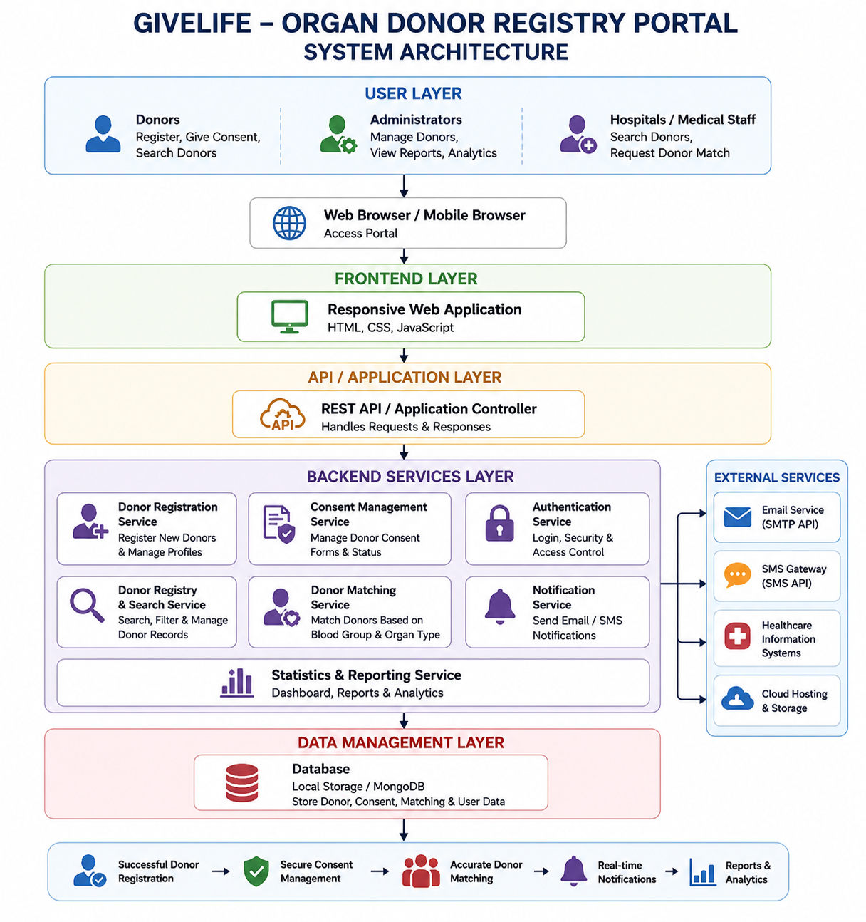

4.2 Description of Each Layer (Frontend, Backend, Database)

Frontend Layer
The Frontend Layer is the user-facing component of the GiveLife – Organ Donor Registry Portal. It is responsible for providing an interactive and user-friendly interface through which donors, administrators, and healthcare personnel can access the system. This layer was developed using HTML, CSS, and JavaScript, which together create responsive web pages and dynamic user interactions.
The frontend includes various modules such as Donor Registration, Consent Management, Donor Registry, Donor Matching, Dashboard Statistics, and Notification Management. Users can enter donor information, submit consent forms, search donor records, perform matching operations, and view statistical information through the graphical interface.
HTML is used to structure the web pages and forms, CSS is used to design attractive layouts and responsive interfaces, and JavaScript provides dynamic functionality such as form validation, search filtering, donor matching logic, and real-time updates. The frontend ensures that users can easily navigate the portal and perform operations without technical difficulties.
The layer also displays notifications and status messages whenever important actions are completed successfully or when errors occur. By providing a simple and intuitive interface, the frontend improves user experience and ensures efficient interaction with the organ donor management system.

Backend Layer
The Backend Layer contains the business logic and functional processing of the GiveLife – Organ Donor Registry Portal. It acts as an intermediary between the frontend interface and the database layer. The backend is responsible for processing user requests, validating information, executing donor matching algorithms, managing donor records, and generating responses for the user interface.
The backend consists of several functional services including:
• Donor Registration Service
• Consent Management Service
• Donor Registry Service
• Donor Matching Service
• Notification Service
• Authentication Service
When a user submits donor information, the backend validates the entered data and processes it according to predefined business rules. The donor matching service applies blood group compatibility rules and organ availability conditions to identify suitable donors for recipients.
The backend also manages record updates, deletions, and status changes. Whenever a donor is matched or removed, the backend updates the corresponding records and communicates the changes to the frontend. Notification services generate alerts and confirmation messages after important operations.

In future versions, the backend can be implemented using technologies such as Node.js, Express.js, Java Spring Boot, or Python Django to support large-scale deployment, advanced security features, and integration with healthcare systems.

Database Layer
The Database Layer is responsible for storing, retrieving, updating, and managing all information used by the GiveLife – Organ Donor Registry Portal. It serves as the central repository for donor records, consent information, matching details, and system statistics.
In the current implementation, data is stored using Browser Local Storage, which allows information to remain available even after the browser is refreshed. Local Storage provides a simple and efficient solution for prototype development and testing purposes.
The database stores information such as:
• Donor ID
• Donor Name
• Age
• Gender
• Blood Group
• Organ Type
• Contact Details
• City Information
• Consent Records
• Matching Status
• Dashboard Statistics
Whenever a user registers as a donor, submits consent, or updates information, the data is stored in the database layer. Similarly, search operations, donor matching, and dashboard updates retrieve information from the stored records.
Although Local Storage is sufficient for demonstration purposes, future versions of the portal can use cloud-based databases such as MongoDB, MySQL, or PostgreSQL. These databases would provide centralized access, better security, higher scalability, automatic backups, and support for multiple users accessing the system simultaneously.
The database layer plays a critical role in ensuring data consistency, reliability, and availability throughout the operation of the GiveLife – Organ Donor Registry Portal.

4.2 Deployment Architecture (Cloud, Local, CI/CD Pipelines)

The deployment architecture of the GiveLife – Organ Donor Registry Portal defines how the application is developed, tested, deployed, and maintained in different environments. A well-designed deployment architecture ensures that the system remains accessible, reliable, scalable, and easy to manage. The architecture consists of three major deployment approaches: Local Deployment, Cloud Deployment, and CI/CD Pipeline Integration. Together, these components support the complete lifecycle of the application from development to production.

4.2.1 Local Deployment Architecture

Local deployment is primarily used during the development and testing phases of the GiveLife Portal. In this environment, the application runs on the developer's local machine without requiring internet connectivity or external hosting services.

The frontend components developed using HTML, CSS, and JavaScript are executed directly through a web browser or a local development server. Donor information, consent records, matching details, and dashboard statistics are stored using Browser Local Storage. This allows developers to test application functionality without requiring a dedicated database server.

Local deployment provides several benefits including rapid development, easy debugging, simplified testing, and reduced deployment costs. Developers can quickly implement new features, identify bugs, and validate system behavior before moving the application to a production environment.

Typical Local Environment:

• Developer Computer

• Web Browser (Chrome, Firefox, Edge)

• HTML, CSS, JavaScript Files

• Browser Local Storage

• Git Repository for Version Control

Local deployment serves as the foundation for system development and ensures that all modules function correctly before cloud deployment.

4.2.2 Cloud Deployment Architecture

Cloud deployment allows the GiveLife Portal to be accessed by users from any location through the internet. In a production environment, the frontend application is hosted on cloud platforms such as Netlify, Vercel, AWS, Azure, or Google Cloud Platform.

When a user accesses the portal, requests are routed through secure web servers that deliver the application interface. Future versions of the system can utilize cloud databases such as MongoDB Atlas, MySQL Cloud Services, or PostgreSQL to store donor information securely and centrally.

Cloud deployment offers several advantages including:

• High Availability

• Global Accessibility

• Automatic Scaling

• Data Backup and Recovery

• Improved Security

• Better Performance

The cloud environment can support multiple users simultaneously, making it suitable for hospitals, healthcare organizations, and organ donation networks. Cloud hosting also allows administrators to monitor application performance and perform updates without interrupting user access.

Cloud Components:

• Frontend Hosting Server

• Cloud Database Server

• Authentication Services

• Notification Services

• Monitoring and Logging Systems

• Backup and Recovery Infrastructure

This deployment model ensures that the portal remains available, secure, and scalable as the number of users increases.

4.2.3 CI/CD Pipeline Architecture

CI/CD (Continuous Integration and Continuous Deployment) is an automated software delivery process that improves development efficiency and deployment reliability. The GiveLife Portal can utilize CI/CD pipelines to automate code integration, testing, building, and deployment activities.

Developers first commit source code changes to a Git repository hosted on GitHub. Whenever changes are pushed to the repository, automated workflows are triggered. These workflows perform code validation, execute automated tests, and build deployment-ready application packages.

If all tests pass successfully, the CI/CD pipeline automatically deploys the updated application to the cloud hosting environment. This reduces manual effort, minimizes deployment errors, and ensures faster software delivery.

Typical CI/CD Workflow:

Developer → GitHub Repository → Automated Build → Testing → Deployment → Production Server

Tools commonly used include:

• Git

• GitHub

• GitHub Actions

• Jenkins

• Docker

• Netlify CI/CD

• Vercel Deployment Pipeline

Benefits of CI/CD Integration:

• Faster Software Releases

• Automated Testing

• Reduced Human Errors

• Improved Code Quality

• Continuous Monitoring

• Rapid Bug Fix Deployment

By implementing CI/CD pipelines, the GiveLife Portal can maintain high software quality while enabling continuous improvements and feature updates.

The deployment architecture ensures that the GiveLife – Organ Donor Registry Portal remains efficient, maintainable, scalable, and ready for future enhancements while supporting reliable access for all users.

CHAPTER -5 DESIGN

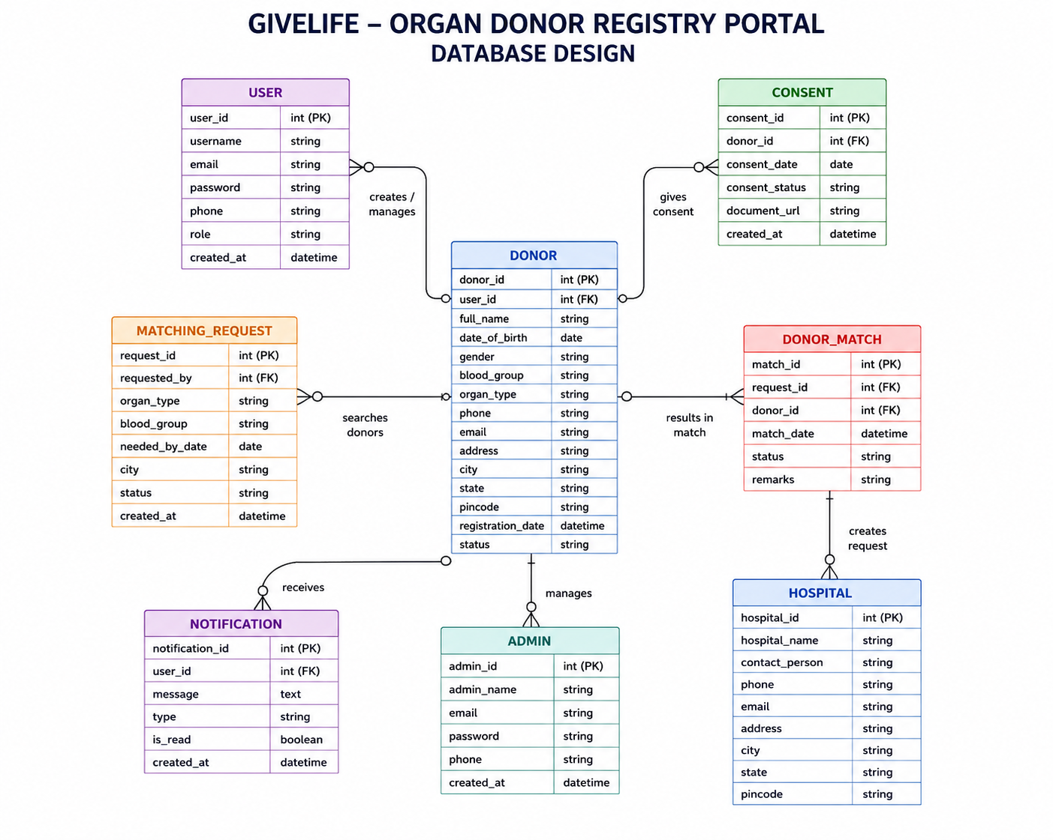

CHAPTER -6 IMPLEMENTATION

Section 6.1 – Module-Wise Implementation

1. Donor Registration Module
The Donor Registration Module is one of the most important and fundamental components of the GiveLife – Organ Donor Registry Portal. It serves as the primary entry point for individuals who wish to register themselves as organ donors and contribute to saving lives through organ transplantation. The effectiveness of the entire organ donation system depends on the accuracy and completeness of the information collected during the registration process. Therefore, this module is designed to provide a simple, secure, and user-friendly environment where potential donors can submit their personal and donation-related information.

The registration process begins when a user accesses the donor registration form available within the portal. The form is designed to collect essential information required for donor identification and future organ matching activities. The information collected includes the donor’s full name, age, gender, blood group, contact number, email address, city, and the organ or organs they are willing to donate. These details help create a complete donor profile that can be utilized by healthcare professionals during donor search and matching operations. The user-friendly interface ensures that individuals from different educational and technical backgrounds can complete the registration process without difficulty.

One of the key features of this module is its comprehensive input validation mechanism. Validation is performed to ensure that all required information is entered correctly and that the donor meets the eligibility criteria established by the system. For example, the donor’s age must fall between 18 and 65 years, as individuals outside this age range may not be eligible for organ donation according to standard guidelines. Similarly, blood group information must be selected from predefined options, and contact details must follow the correct format. These validation procedures help maintain data accuracy and prevent incorrect or incomplete records from being stored in the system.

After successful validation, the system automatically generates a unique Donor ID for each registered donor. This identifier serves as the donor’s permanent reference number within the portal and helps distinguish one donor from another. The Donor ID can be used in future operations such as consent management, donor searches, record updates, and organ matching processes. The automatic generation of unique identifiers improves record organization and eliminates the possibility of duplicate entries.

The donor information is then stored securely within the system using browser-based Local Storage. This storage mechanism allows donor records to remain available even after the browser is closed and reopened. The stored information can later be retrieved, displayed, modified, or matched with recipient requirements whenever necessary. The use of Local Storage provides a lightweight and efficient solution for maintaining donor records without requiring a dedicated database server.

The module also includes usability features that improve the overall user experience. After a successful registration, a confirmation notification is displayed to inform the donor that the registration has been completed successfully. Additionally, a reset functionality is provided to clear all form fields and prepare the interface for a new registration. This feature is particularly useful when multiple registrations are performed on the same device.

In conclusion, the Donor Registration Module serves as the foundation of the GiveLife – Organ Donor Registry Portal. By collecting accurate donor information, validating user inputs, generating unique donor identifiers, and securely storing records, this module ensures the creation of a reliable donor database. Its efficient design, user-friendly interface, and robust validation mechanisms contribute significantly to the overall effectiveness of the organ donation management system.

2. Consent Management Module
The Consent Management Module is a critical component of the GiveLife – Organ Donor Registry Portal because it ensures that organ donation activities are conducted in a legal, ethical, and transparent manner. Organ donation involves sensitive personal and medical decisions, making informed consent an essential requirement before any donor information can be used for transplantation purposes. This module is specifically designed to obtain, record, and manage donor consent while ensuring that individuals fully understand the implications of their decision to become organ donors.

The primary objective of the Consent Management Module is to provide donors with complete information regarding the organ donation process and allow them to make informed decisions voluntarily. When users access this module, they are presented with a detailed consent agreement that clearly explains the purpose of organ donation, donor rights, privacy protection measures, eligibility conditions, and the procedures involved in the donation process. The agreement is written in a clear and understandable format so that users can review all relevant information before providing their consent.

A major feature of this module is its declaration and verification process. To confirm their willingness to participate, donors are required to select specific declaration checkboxes indicating that they have read and understood the consent agreement. These declarations typically state that the donor voluntarily agrees to donate organs, understands the associated procedures, and authorizes the system to maintain their information within the donor registry. This step ensures that consent is obtained explicitly rather than assumed, thereby maintaining ethical standards and legal compliance.

In addition to the declaration checkboxes, donors must provide their full name and the date of consent. These details serve as an electronic acknowledgment of the agreement and create a documented record of the donor’s decision. The module may also include an optional field where donors can enter their existing Donor ID if they have already completed the registration process. This feature helps link the consent record with the corresponding donor profile, ensuring consistency within the system database.

The module incorporates validation mechanisms to ensure that all required fields are completed before submission. If a donor fails to accept the declarations or leaves mandatory information incomplete, the system displays an appropriate error message and prevents submission. This validation process guarantees that consent records are complete and legally valid. Such checks help eliminate incomplete or invalid consent entries and maintain the reliability of donor records.

Once the consent form is submitted successfully, the system stores the consent information securely and generates a confirmation notification through the toast notification system. This notification informs the donor that their consent has been successfully recorded. Providing immediate feedback enhances transparency and reassures users that their information has been processed correctly. The confirmation record can also serve as evidence of consent if required for future administrative or healthcare purposes.

The Consent Management Module also contributes to trust and accountability within the organ donation ecosystem. By maintaining documented consent records, the portal ensures that donor intentions are respected and that healthcare professionals can verify authorization before proceeding with donation-related activities. This not only protects donor rights but also supports compliance with healthcare regulations and ethical standards governing organ transplantation.
Furthermore, the module is designed with future scalability in mind. Advanced versions may include digital signatures, secure document uploads, biometric verification, and integration with government healthcare systems. These enhancements would strengthen the authenticity of consent records and provide additional legal safeguards.

In conclusion, the Consent Management Module plays a vital role in the GiveLife – Organ Donor Registry Portal by ensuring that organ donation decisions are informed, voluntary, and properly documented. Through detailed agreements, declaration verification, validation procedures, secure storage, and confirmation mechanisms, the module promotes ethical practices, legal compliance, transparency, and trust. As a result, it forms a strong foundation for responsible organ donation management and helps ensure that donor wishes are respected throughout the transplantation process.

3. Donor Registry & Search Module
The Donor Registry & Search Module serves as the central data management component of the GiveLife – Organ Donor Registry Portal. It is responsible for maintaining, organizing, displaying, and managing all donor records stored within the system. As the number of registered donors increases, it becomes essential to have a structured and efficient mechanism for accessing donor information. This module provides healthcare professionals, administrators, and authorized personnel with the tools necessary to quickly locate and manage donor records, thereby supporting effective organ donation and transplantation activities.

The primary purpose of this module is to maintain a comprehensive registry of all individuals who have registered as organ donors through the portal. Every donor record contains important information such as Donor ID, full name, age, gender, blood group, city, organ type, contact information, and donation status. These records are displayed in a structured table format, allowing users to view and analyze donor information in an organized manner. The clear presentation of data improves readability and helps users access important information without difficulty.

One of the most significant features of this module is its search functionality. As donor databases grow larger, manually locating specific records becomes time-consuming and inefficient. To address this challenge, the module provides a powerful search mechanism that allows users to find donors using various criteria. Healthcare personnel can search by donor name, blood group, city, organ type, or donor identification number. The search process is performed instantly, and matching results are displayed dynamically, improving both efficiency and user experience.

In addition to search functionality, the module includes advanced filtering capabilities that further enhance data accessibility. Users can filter donor records based on blood group, organ type, availability status, or location. For example, a healthcare professional searching for kidney donors with a specific blood group can quickly narrow the results using available filters.
These filtering options significantly reduce the time required to identify suitable donors and improve decision-making during critical medical situations.

The Donor Registry & Search Module also supports donor record management operations. Authorized users can update donor information whenever necessary to ensure that records remain accurate and up-to-date. Changes in contact information, city, organ preferences, or donation status can be modified through the management interface. This flexibility ensures that the donor database reflects current information and remains reliable for future matching activities.

Another important feature of this module is status management. Each donor is assigned a status that indicates their current availability for organ donation. Common statuses include “Available” and “Matched.” When a donor is successfully matched with a recipient through the Donor Matching Module, their status is automatically updated. This prevents duplicate allocations and ensures that healthcare personnel work only with currently available donor records. The automatic synchronization of status information across the portal improves consistency and reduces administrative errors.

The module also includes record deletion functionality. In certain situations, administrators may need to remove outdated, duplicate, or invalid records from the registry. The deletion feature allows authorized users to manage database cleanliness while maintaining the accuracy of stored information. Appropriate confirmation messages are displayed before deletion to prevent accidental removal of important records.

From a performance perspective, the module is designed to provide real-time updates without requiring page reloads. Whenever records are added, updated, matched, or deleted, the displayed registry updates automatically. This dynamic behavior enhances usability and provides users with immediate access to the latest information.

In conclusion, the Donor Registry & Search Module is a vital component of the GiveLife – Organ Donor Registry Portal. By providing efficient donor record management, advanced search capabilities, filtering options, status tracking, and real-time updates, the module ensures that donor information remains accessible, accurate, and organized. Its functionality supports healthcare professionals in identifying suitable donors quickly and contributes significantly to the overall effectiveness of organ donation management.

4. Donor Matching Module
The Donor Matching Module is one of the most important and critical components of the GiveLife – Organ Donor Registry Portal. The primary purpose of this module is to identify suitable organ donors for recipients who require organ transplantation. Since organ transplantation is a highly sensitive medical procedure, finding a compatible donor is essential for increasing the chances of a successful transplant and improving patient survival rates. This module automates the donor selection process by analyzing donor records and applying compatibility rules, thereby reducing manual effort and improving efficiency.

The matching process begins when healthcare personnel or authorized users enter the recipient’s medical requirements into the system. These requirements typically include the recipient’s blood group and the specific organ needed for transplantation, such as a kidney, liver, heart, lungs, pancreas, or cornea. Once this information is provided, the system searches through the donor registry and evaluates all available donor records to identify potential matches. This automated process significantly reduces the time required to locate suitable donors compared to manual searching methods.

One of the key features of the Donor Matching Module is its blood group compatibility analysis. Blood group compatibility plays a major role in determining whether a donor is medically suitable for a recipient. The system incorporates established blood compatibility rules to ensure accurate matching. For example, O-negative donors are considered universal donors because they can donate organs to recipients of any blood group. Similarly, AB-positive recipients are universal recipients because they can receive organs from all blood groups. By applying these compatibility rules, the module ensures that only medically suitable donor-recipient combinations are considered.

In addition to blood group matching, the system verifies organ compatibility. The module compares the organ required by the recipient with the organs registered by available donors. Only those donors who have agreed to donate the requested organ are included in the matching process. This additional verification improves the accuracy of search results and helps healthcare professionals identify appropriate donors more efficiently.

The module also considers donor availability status before displaying results. Only donors whose status is marked as “Available” are included in the matching process. Donors who have already been matched with recipients or whose records are inactive are automatically excluded. This prevents duplicate allocations and ensures that the donor registry remains accurate and up-to-date. By filtering records based on availability, the system improves reliability and supports effective organ allocation management.

Once a compatible donor is identified, the system displays detailed donor information, including Donor ID, donor name, blood group, organ type, city, and contact details. Healthcare personnel can review this information and evaluate the suitability of the donor. If the donor is approved for transplantation, the user can confirm the match through the system interface. Upon confirmation, the donor’s status is automatically updated from “Available” to “Matched” across the entire portal. This status update ensures that the donor is no longer considered in future matching operations, thereby maintaining consistency within the registry.

Another important advantage of the Donor Matching Module is its ability to improve decision-making speed. Organ transplantation often involves time-sensitive situations where delays can significantly impact patient outcomes.

By automating compatibility analysis and donor identification, the module enables healthcare professionals to make faster and more informed decisions. The reduction in manual workload also allows medical staff to focus on patient care and transplantation procedures rather than spending excessive time searching donor records.
The module has also been designed with future scalability in mind. Advanced versions of the system may incorporate additional matching criteria such as tissue compatibility, medical history, donor health status, geographical proximity, and artificial intelligence-based recommendation systems. These enhancements would further improve matching accuracy and increase the success rate of organ transplantation procedures.

In conclusion, the Donor Matching Module serves as the core functionality of the GiveLife – Organ Donor Registry Portal. By automating donor identification, applying blood group compatibility rules, verifying organ availability, managing donor status, and supporting rapid decision-making, the module significantly improves the efficiency and reliability of the organ donation process. Its ability to connect suitable donors with recipients contributes directly to the portal’s mission of saving lives through effective organ donation management.

5. Notification & Statistics Module
The Notification & Statistics Module is an essential component of the GiveLife – Organ Donor Registry Portal that enhances user interaction, improves system transparency, and provides valuable insights into the overall performance of the organ donation registry. This module serves two primary functions: delivering real-time notifications to users regarding system activities and displaying statistical information that reflects the current status of donor registration and organ matching operations. By combining communication and analytical features, the module ensures that users remain informed while administrators gain a clear understanding of system performance.

One of the major responsibilities of this module is managing notifications. In any interactive application, users need immediate feedback regarding their actions. The GiveLife Registry Portal addresses this requirement through a toast notification system. Toast notifications are small, temporary messages that appear on the screen whenever a significant action is performed. These messages provide instant confirmation that a process has been completed successfully or alert users when an error occurs. The notification system improves user confidence by ensuring that every action receives an immediate response from the application.

For example, when a donor successfully completes the registration process, a notification appears confirming that the donor has been registered successfully. Similarly, after a consent form is submitted, the system generates a message indicating that consent has been recorded. Notifications are also displayed when donor records are updated, deleted, or successfully matched with recipients. In situations where users enter incomplete or invalid information, error notifications help identify the problem and guide users toward corrective action. This immediate feedback improves usability and reduces confusion during system interaction.

Another important feature of the Notification & Statistics Module is its ability to provide real-time statistical information about the donor registry. Statistical data plays a significant role in monitoring the effectiveness of organ donation programs and evaluating overall system performance. The module continuously analyzes donor records and generates key metrics that are displayed on the dashboard or home page. These statistics help administrators, healthcare professionals, and users understand the current state of the organ donor registry.

The statistics section typically displays information such as the total number of registered donors, the number of donors currently available for donation, and the number of donors who have already been matched with recipients. These figures are updated automatically whenever new donor records are added, existing records are modified, or successful matches occur. The dynamic nature of these statistics ensures that users always have access to accurate and up-to-date information without requiring manual refreshes.

The module also contributes to decision-making and performance evaluation. Healthcare organizations can use statistical data to identify trends in donor registrations, monitor donor availability, and assess the effectiveness of awareness campaigns. For example, a steady increase in donor registrations may indicate successful public awareness efforts, while low availability rates may highlight the need for additional recruitment initiatives. Such insights support better planning and resource allocation within organ donation programs.

From a technical perspective, the module continuously monitors changes within the donor registry and updates displayed information in real time. This ensures synchronization between the database and the user interface. The efficient handling of notifications and statistics contributes to a smooth user experience while minimizing system overhead.

The Notification & Statistics Module also promotes transparency and accountability. By providing clear feedback regarding system actions and displaying measurable performance indicators, users gain confidence in the reliability of the portal. Administrators can easily track donor activity, monitor system growth, and evaluate operational effectiveness through the available statistics.

In conclusion, the Notification & Statistics Module plays a crucial role in the GiveLife – Organ Donor Registry Portal by enhancing communication, improving user experience, and providing valuable analytical insights. Through real-time notifications and dynamically updated statistical information, the module ensures transparency, supports informed decision-making, and contributes significantly to the efficient management of organ donation activities. Its combination of communication and reporting capabilities makes it an indispensable component of the overall system.

Section 6.2 – Front-End Logic (UI Rendering and State Management)

The front-end logic of the GiveLife – Organ Donor Registry Portal is responsible for handling user interactions, displaying information on the screen, and managing the flow of data within the application. Developed using HTML, CSS, and JavaScript, the front-end layer provides a responsive and user-friendly interface that allows users to interact with various features of the portal efficiently. It acts as the communication layer between users and the underlying data storage system, ensuring smooth operation and real-time updates throughout the application.

UI rendering refers to the process of displaying information and updating visual components on the web page whenever data changes occur. In the GiveLife Registry Portal, several user interface elements such as donor registration forms, consent forms, donor registry tables, search filters, matching results, notifications, and statistical dashboards are dynamically rendered using JavaScript. Instead of reloading the entire page after every action, only the affected components are updated. This approach improves performance, reduces loading time, and provides a seamless user experience.

When a new donor registers through the portal, the registration form collects and validates the entered information. After successful validation, the donor record is stored and immediately displayed in the donor registry section. The donor count shown on the dashboard is also updated automatically. Similarly, when a donor is matched with a recipient, the donor's status changes from “Available” to “Matched,” and the updated information is reflected throughout the application. These dynamic updates ensure consistency and provide users with the latest information at all times.

State management is another important aspect of the front-end logic. The term “state” refers to the current data and information maintained by the application during its operation. In the GiveLife Registry Portal, the state includes donor records, consent information, donor status, matching results, notification messages, and statistical data. JavaScript manages this state by storing and retrieving information from Local Storage. Whenever users perform actions such as registration, deletion, updating records, or confirming donor matches, the application state is modified accordingly.

The search and filtering functionalities are also dependent on state management. Users can search donor records using donor names, blood groups, cities, or organ types. The application dynamically filters the displayed records without changing the original dataset stored in Local Storage. This allows users to quickly locate specific donors while maintaining data integrity and performance.

The notification system forms an important part of the front-end logic. Toast notifications are generated whenever significant actions occur within the portal. Success notifications confirm completed actions such as donor registration, consent submission, and donor matching. Error notifications alert users when invalid information is entered or when required fields are left incomplete. These notifications provide immediate feedback and improve overall usability.

The statistics dashboard is another example of dynamic UI rendering. The dashboard continuously displays information such as the total number of registered donors, available donors, and matched donors. Whenever donor records are added, updated, or removed, these statistics are recalculated and updated automatically. This ensures that administrators and users always have access to accurate and current information regarding the donor registry.

Overall, the front-end logic of the GiveLife – Organ Donor Registry Portal plays a crucial role in delivering a smooth and interactive user experience. Through dynamic UI rendering and efficient state management, the application ensures real-time updates, accurate data presentation, responsive interactions, and effective management of organ donation information. These capabilities significantly enhance the usability, reliability, and efficiency of the portal while supporting its objective of promoting and managing organ donation activities.

6.3 API Integration
API (Application Programming Interface) integration is an important aspect of modern web application development because it enables communication between different software systems and external services. In the GiveLife – Organ Donor Registry Portal, API integration plays a significant role in enhancing functionality, improving user experience, and supporting future scalability. Although the current implementation of the portal primarily uses HTML, CSS, JavaScript, and Local Storage for managing donor information, the system architecture has been designed to support future integration with various APIs and healthcare-related services. These integrations can help automate processes, improve communication, and facilitate real-time data exchange.

The primary purpose of API integration in the GiveLife Registry Portal is to allow seamless interaction between the portal and external systems. APIs act as bridges that enable applications to send and receive data securely without exposing internal system details. Through API integration, donor information, recipient records, and healthcare data can be exchanged efficiently between hospitals, transplant centers, and healthcare organizations.
This improves coordination among stakeholders involved in organ donation and transplantation activities.

One potential API integration is with hospital management systems. Hospitals often maintain electronic medical records containing patient details, transplant requirements, and donor eligibility information. By integrating with healthcare APIs, the portal can access relevant information in real time, reducing manual data entry and improving data accuracy. Such integration would enable healthcare professionals to make faster and more informed decisions regarding donor-recipient matching and organ allocation.
The portal can also integrate with email service APIs such as EmailJS, SendGrid, or SMTP-based services. These APIs allow the system to send automated emails for donor registration confirmations, consent acknowledgments, awareness campaign updates, and important notifications. Automated communication ensures that donors remain informed about their registration status and encourages continued engagement with organ donation initiatives.

SMS gateway APIs provide another valuable integration opportunity. Services such as Twilio and Fast2SMS can be used to send real-time notifications directly to users’ mobile devices. SMS alerts can be utilized for appointment reminders, emergency notifications, donor matching confirmations, and urgent transplantation-related communications. Since organ transplantation often involves time-sensitive situations, instant communication through SMS can significantly improve response times.

Cloud service APIs can further enhance the functionality and scalability of the GiveLife Registry Portal. Platforms such as Google Firebase, MongoDB Atlas, Amazon Web Services (AWS), and Microsoft Azure provide secure cloud storage, centralized databases, backup services, and scalable infrastructure. By integrating these services, the portal can support larger numbers of users, improve data accessibility, and ensure reliable system performance across multiple healthcare institutions.

Security-focused APIs also play an important role in protecting sensitive donor information. Authentication services such as Firebase Authentication, Google Sign-In, and OAuth-based systems can provide secure login and user verification mechanisms. These APIs help prevent unauthorized access and ensure that only authenticated users can access confidential donor and recipient records. Additional security features such as encrypted communication and role-based access control can further strengthen data protection.

Location-based APIs such as Google Maps API can also be integrated into the portal. These services can help users locate nearby hospitals, transplant centers, blood banks, and healthcare facilities. Such functionality improves accessibility and supports better coordination between donors, recipients, and medical institutions.

In conclusion, API integration significantly enhances the capabilities of the GiveLife – Organ Donor Registry Portal by enabling communication with external systems and services. Through integration with healthcare databases, email services, SMS gateways, cloud platforms, authentication providers, and location-based services, the portal can provide improved functionality, security, scalability, and user experience. As the system evolves, API integration will play a crucial role in transforming the portal into a comprehensive and efficient organ donation management platform capable of supporting healthcare organizations and saving lives through effective donor-recipient coordination.

6.4 Authentication and Authorisation

Authentication and authorization are critical security components of the GiveLife – Organ Donor Registry Portal. Since the portal manages sensitive information related to organ donors, consent records, and donor-recipient matching activities, it is essential to implement proper security measures that protect user data and ensure controlled access to system resources. These mechanisms help maintain privacy, data integrity, confidentiality, and trust within the organ donation ecosystem. Without proper authentication and authorization, unauthorized users could gain access to confidential donor information, leading to security risks and potential misuse of data.

Authentication is the process of verifying the identity of a user before granting access to the application. It answers the fundamental security question: “Who is the user attempting to access the system?” In a fully developed implementation of the GiveLife Registry Portal, users would be required to provide valid login credentials such as a username, email address, and password. The system would compare these credentials against stored records and verify their authenticity before granting access. Only users with valid credentials would be allowed to enter the system and access its functionalities.

To further strengthen security, advanced authentication methods can be integrated into the portal. Features such as email verification, One-Time Passwords (OTP), and Multi-Factor Authentication (MFA) provide additional layers of protection. Email verification confirms that users have access to the registered email address, while OTP-based authentication requires users to enter a temporary code sent to their mobile device or email account. Multi-Factor Authentication combines multiple verification methods, significantly reducing the risk of unauthorized access even if login credentials become compromised.

Authorization is the process that determines what actions an authenticated user is permitted to perform within the system. While authentication verifies identity, authorization defines access rights and permissions. After successful login, the portal assigns permissions based on the user's role and responsibilities. This process ensures that users can only access information and functionalities that are relevant to their authorized tasks.

The GiveLife Registry Portal can implement Role-Based Access Control (RBAC) to manage user permissions effectively. Under this approach, different categories of users are assigned specific roles. For example, administrators have complete control over the system and can view, update, manage, and delete donor records. Healthcare professionals may have access to donor search and matching functionalities but may not be permitted to modify administrative settings. Donors themselves may only be able to register, update personal information, and submit consent forms. By restricting access based on predefined roles, the system minimizes security risks and prevents unauthorized activities.

Authorization also helps protect sensitive donor and recipient information from accidental or intentional misuse. Certain data, such as medical records, donor status information, and consent documentation, should only be accessible to authorized personnel. Through proper authorization controls, the portal ensures that confidential information remains protected and accessible only to individuals with legitimate responsibilities.

Session management is another important aspect of authentication and authorization. Once users successfully log in, the system creates a secure session that remains active during their interaction with the portal. Sessions help maintain user identity across different pages and functionalities. Secure session handling prevents unauthorized access and ensures that users are automatically logged out after a period of inactivity, reducing potential security vulnerabilities.
Data protection is further enhanced through secure password management practices. User passwords should never be stored in plain text. Instead, passwords can be encrypted or hashed using secure cryptographic algorithms before being stored in the database. This approach ensures that even if unauthorized individuals gain access to stored data, they cannot easily retrieve user credentials.

In future versions of the GiveLife Registry Portal, authentication and authorization mechanisms can be integrated with external identity providers such as Google Sign-In, Firebase Authentication, OAuth, or government healthcare authentication services. These integrations can simplify user management while maintaining high levels of security and reliability.
In conclusion, authentication and authorization play a vital role in securing the GiveLife – Organ Donor Registry Portal. Authentication verifies user identities, while authorization controls access to system resources and functionalities. Together, these mechanisms protect sensitive healthcare information, prevent unauthorized access, support compliance with data protection standards, and maintain the integrity of the organ donation management process. Their implementation ensures that the portal remains secure, reliable, and trustworthy for donors, healthcare professionals, and administrators.

7.1 List of Main Features

The GiveLife – Organ Donor Registry Portal is a comprehensive web-based application developed to simplify and improve the process of organ donor registration, donor management, consent handling, and donor-recipient matching. The system incorporates several important features that work together to create an efficient, reliable, and user-friendly organ donation management platform. These features help healthcare organizations, administrators, and donors participate effectively in the organ donation process.

1. Donor Registration Feature
The donor registration feature allows individuals to enroll themselves as organ donors through an online registration form. Users provide important details such as name, age, gender, blood group, contact number, city, email address, and the organs they wish to donate. The system validates all inputs before accepting the registration. Upon successful registration, a unique Donor ID is generated and assigned to each donor. This feature serves as the foundation of the entire donor management system by creating a structured database of potential organ donors.

2. Consent Management Feature
The portal includes a dedicated consent management system that enables donors to provide informed consent for organ donation. Before their information is used within the registry, donors must read and agree to the donation terms and conditions. The consent form includes declarations, acknowledgments, and confirmation details that ensure ethical and legal compliance. This feature promotes transparency and protects donor rights throughout the organ donation process.

3. Donor Registry Management
All donor information is stored in a centralized donor registry. This feature provides healthcare professionals and administrators with access to complete donor records in an organized format. The registry displays information such as donor ID, donor name, age, blood group, city, organ type, and donation status. The centralized structure improves record management and facilitates efficient donor monitoring.

4. Advanced Search Functionality
The search feature enables users to quickly locate donor records using various search criteria. Administrators and healthcare personnel can search by donor name, blood group, city, organ type, or donor ID. This functionality significantly reduces the time required to identify relevant donor records and improves the efficiency of donor management activities.

5. Filter-Based Record Management
The portal provides advanced filtering capabilities that allow users to narrow search results according to specific requirements. Records can be filtered based on blood group, organ type, donor availability status, and location. This feature is particularly useful when healthcare professionals need to identify compatible donors within a large database.

6. Intelligent Donor Matching System
One of the most important features of the portal is the donor matching system. The application automatically compares recipient requirements with available donor records and applies blood group compatibility rules to identify suitable matches. The system evaluates organ type, donor availability, and blood compatibility before presenting matching results. This automated approach improves accuracy and reduces the time required to find appropriate donors.

7. Donor Status Tracking
The system continuously tracks the status of each registered donor. Donors may have statuses such as “Available” or “Matched.” Whenever a successful donor-recipient match occurs, the donor's status is automatically updated throughout the application. This prevents duplicate allocations and ensures that donor records remain accurate and up to date.

8. Real-Time Notification System
The portal includes a toast notification system that provides instant feedback to users. Notifications are displayed whenever important actions occur, such as successful registration, consent submission, donor matching, record updates, or record deletion. These notifications improve user experience by keeping users informed about system activities and operation outcomes.

9. Dynamic Statistics Dashboard
The home page contains a statistics dashboard that provides real-time information about the donor registry. Important metrics such as total registered donors, available donors, and matched donors are displayed and updated automatically whenever changes occur in the database. This feature provides administrators with valuable insights into system performance and donor availability.

10. Data Validation and Error Handling
The application incorporates comprehensive validation mechanisms to ensure data accuracy and consistency. All user inputs are verified before being processed and stored. Validation checks prevent incomplete, incorrect, or duplicate information from entering the system. Error messages guide users in correcting mistakes and completing forms successfully.

11. Local Storage Integration
The current version of the GiveLife Registry Portal uses browser Local Storage to maintain donor and consent records. This feature enables persistent data storage without requiring a separate database server. Information remains available even after the browser is closed and reopened, ensuring continuity and reliability.

12. User-Friendly Interface
The portal is designed with simplicity and usability in mind. The interface provides clear navigation menus, responsive layouts, intuitive forms, and well-organized content sections. Users can easily access different modules without requiring advanced technical knowledge. The responsive design ensures compatibility across desktops, laptops, tablets, and mobile devices.

13. Dynamic User Interface Rendering
The system updates content dynamically without requiring page refreshes. Whenever donor records are added, modified, deleted, or matched, the interface automatically reflects these changes. Dynamic rendering improves application performance and provides a smooth user experience.

14. Secure Data Handling
The portal incorporates security measures such as input validation, controlled access, and proper data management practices to protect sensitive donor information. These mechanisms help maintain data integrity and reduce the risk of unauthorized modifications or misuse of information.

15. Scalability and Future Enhancement Support
The system has been developed with future expansion in mind. The architecture supports future integration with cloud databases, hospital management systems, authentication services, SMS gateways, email APIs, healthcare networks, and advanced donor matching technologies. This scalability ensures that the platform can continue evolving to meet growing healthcare requirements.

In conclusion, the GiveLife – Organ Donor Registry Portal combines multiple powerful features to create a complete organ donation management solution. From donor registration and consent management to donor matching, notifications, statistics, and secure data handling, every feature contributes toward improving the efficiency, reliability, and effectiveness of organ donation activities. Together, these functionalities support the portal's primary objective of connecting donors with recipients and promoting life-saving organ transplantation.

7.2 HOW DOES IT WORK?

The GiveLife – Organ Donor Registry Portal is a web-based application developed to simplify the process of organ donor registration, consent management, donor record maintenance, and donor-recipient matching. The portal acts as a centralized platform where potential organ donors can register themselves, provide consent for organ donation, and make their information available for future transplantation needs. The system is designed to ensure accuracy, efficiency, transparency, and ease of access throughout the organ donation process.

The workflow begins when a user visits the portal and accesses the donor registration section. The registration form collects essential information such as the donor's full name, age, gender, blood group, contact details, city, and the organs they are willing to donate. Before the information is accepted, the system performs validation checks to ensure that all mandatory fields are completed correctly. Age restrictions, contact number formats, and blood group selections are verified to maintain data accuracy. Once all validations are successful, a unique Donor ID is automatically generated and assigned to the donor. This identifier serves as a permanent reference for future operations within the portal.

After completing the registration process, the donor proceeds to the Consent Management Module. Organ donation requires informed consent because it involves important legal and ethical considerations. The portal presents the donor with a detailed consent agreement explaining the purpose of organ donation, donor rights, privacy protection measures, and donation conditions.

The donor must carefully review this information and confirm agreement by selecting the required declaration checkboxes and providing their name and date. Once submitted, the consent record is stored within the system and linked to the donor profile. This step ensures that all donation activities are supported by documented authorization.

Once registration and consent are completed, the donor's information becomes part of the central donor registry. The donor registry functions as a structured database that stores and organizes all donor records. Administrators and healthcare personnel can access this registry to view donor details, update records, monitor donor availability, and manage organ donation activities. Each donor record contains comprehensive information including donor ID, blood group, organ type, location, and donation status. This centralized approach ensures that all donor information remains organized and easily accessible.

The portal provides advanced search and filtering mechanisms to improve accessibility and efficiency. Healthcare professionals can search for donors using criteria such as donor name, city, blood group, organ type, or donor ID. Filtering options allow users to narrow results based on donor availability and specific medical requirements. These capabilities are particularly valuable when dealing with large donor databases, as they significantly reduce the time required to locate relevant records.

The most critical functionality of the system is the Donor Matching Module. When a patient requires an organ transplant, healthcare personnel enter the recipient's blood group and the organ required into the system. The portal then analyzes all available donor records and applies blood group compatibility rules to identify suitable matches. Compatibility is determined based on medical standards that define which blood groups can donate to or receive from others. In addition to blood compatibility, the system verifies that the donor has agreed to donate the requested organ and is currently available for donation.

Once compatible donors are identified, the system displays a list of matching donor records. Healthcare personnel can review donor information and select the most appropriate donor based on medical and logistical considerations. After confirming a match, the donor's status is automatically updated from "Available" to "Matched." This update is reflected throughout the application, preventing duplicate allocation of the same donor and maintaining data consistency across all modules.

The portal also incorporates a real-time notification system that provides immediate feedback to users. Whenever significant actions occur, such as successful donor registration, consent submission, donor matching, record updates, or donor deletion, the system displays toast notifications. These notifications help users understand the outcome of their actions and improve the overall user experience by providing clear and timely communication.

Another important component is the statistics dashboard. The dashboard continuously monitors donor activity and automatically updates key statistics, including the total number of registered donors, available donors, and matched donors. These statistics provide administrators and healthcare organizations with valuable insights into donor availability and system performance. The dynamic nature of the dashboard ensures that all displayed information remains current and accurate.

The portal stores data using browser-based Local Storage, allowing donor records and consent information to persist even after the browser is closed. This approach provides a lightweight and efficient storage mechanism suitable for the current implementation. Future versions of the system can integrate cloud databases and healthcare information systems to support larger-scale deployment and multi-user access.

Overall, the GiveLife – Organ Donor Registry Portal operates through a sequence of interconnected processes that include donor registration, consent collection, data storage, donor management, donor matching, notification handling, and statistical reporting. Each module contributes to the efficient management of organ donation information, ensuring that healthcare professionals can quickly identify suitable donors and facilitate life-saving organ transplantation procedures. By automating these processes and maintaining accurate records, the portal helps create a reliable, transparent, and effective organ donation management system.

CHAPTER -8 TESTING

8.1 Postman Testing (Frontend/Backend)

Postman Testing is an essential part of the software testing process that helps developers verify the functionality, reliability, and correctness of APIs used within an application. In the GiveLife – Organ Donor Registry Portal, Postman was utilized to test the communication between the frontend interface and backend services. The primary objective of Postman testing was to ensure that all data transactions related to donor registration, consent management, donor matching, and donor record management were processed accurately and efficiently.

The testing process began by creating API requests corresponding to different functionalities of the portal. Various HTTP methods such as GET, POST, PUT, and DELETE were used to perform different operations. POST requests were used to submit donor registration information and consent records. These requests contained data such as donor name, age, blood group, city, contact information, and organ donation preferences. The system was expected to validate the submitted information and return a successful response along with a unique donor identifier.

GET requests were used to retrieve donor information from the system. These requests allowed testers to verify that donor records were correctly stored and could be accessed whenever required. The responses were carefully analyzed to ensure that all donor details were displayed accurately and consistently. Testing confirmed that the retrieval process worked correctly and provided complete donor information.

PUT requests were utilized to test record modification functionality. Existing donor records were updated with new information such as phone numbers, city details, organ preferences, and donor status. After each update operation, the system was queried again to confirm that the changes had been successfully applied. This process ensured that record modification functionality operated reliably.

DELETE requests were tested to verify donor record removal functionality. Selected donor records were deleted, and subsequent retrieval attempts confirmed that the records were no longer available in the system. This testing ensured that deletion operations were functioning correctly without affecting unrelated donor information.

The donor matching functionality was also tested using Postman. Recipient details such as blood group and required organ were submitted to the matching API. The system processed the request and returned a list of compatible donors based on blood compatibility rules and organ availability. These results were compared against expected outcomes to validate the accuracy of the matching algorithm.

Error handling was another important aspect of Postman testing. Invalid requests containing incomplete information, incorrect blood groups, missing fields, and invalid donor IDs were submitted intentionally. The portal successfully generated appropriate error messages and returned suitable HTTP status codes, demonstrating effective validation and error management.

Response validation was performed by verifying status codes such as 200 (OK), 201 (Created), 400 (Bad Request), and 404 (Not Found). The response body was also examined to ensure that returned data matched expected values. Through comprehensive Postman testing, the GiveLife – Organ Donor Registry Portal was validated for functionality, accuracy, and reliability, ensuring smooth communication between frontend and backend components.

8.2 Integration Testing

Integration Testing is a software testing technique used to verify the interaction between multiple modules within an application. The main objective is to ensure that all components work together seamlessly and exchange data correctly. In the GiveLife – Organ Donor Registry Portal, integration testing played a crucial role in validating the communication between different modules such as Donor Registration, Consent Management, Donor Registry, Search and Filter, Donor Matching, Notification System, and Statistics Dashboard.

The first integration test focused on the interaction between the Donor Registration Module and the Donor Registry Module. When a user completed the donor registration form, the submitted information was expected to be automatically transferred to the donor registry. Testing confirmed that newly registered donors appeared immediately in the registry with all relevant details, including Donor ID, blood group, organ type, city, and donor status.

The integration between the Consent Management Module and donor records was also thoroughly tested. After registration, donors were required to provide consent for organ donation. The system successfully linked consent information with the appropriate donor profiles using donor identifiers. This ensured that consent records remained associated with the correct donor throughout the system.

Another important integration test involved the Search and Filter functionality. Whenever donor records were added, modified, or removed, the search system reflected the updated information instantly. Users could search donors by name, blood group, city, or organ type, and the results accurately represented the current state of the donor registry.

The Donor Matching Module was one of the most critical areas of integration testing. Recipient information was entered into the system, and the matching module accessed donor records from the registry to identify compatible donors. Blood compatibility rules and organ availability criteria were applied automatically. Testing verified that the matching process retrieved correct donor records and generated accurate results.

The Notification Module was integrated with all major system operations. Whenever a donor registered, submitted consent, updated information, or was successfully matched, the notification system displayed appropriate success messages. Error notifications were also triggered when invalid information was entered. This integration improved user awareness and system usability.

The Statistics Dashboard was tested to ensure real-time synchronization with donor records. Whenever changes occurred within the donor registry, the dashboard automatically updated donor counts, available donor numbers, and matched donor statistics. This demonstrated effective communication between the dashboard and underlying data modules.

Performance and reliability were also evaluated during integration testing. Multiple operations such as registrations, updates, searches, and matching activities were performed consecutively. The portal maintained stable performance and accurate data synchronization throughout the testing process. The successful completion of integration testing confirmed that all modules operated together as a unified and efficient organ donor management system.

8.3 Tools Used for Testing
1. Postman
Postman is a widely used API testing tool that helps developers test and validate communication between frontend and backend components. In the GiveLife – Organ Donor Registry Portal, Postman was used to send HTTP requests such as GET, POST, PUT, and DELETE for donor registration, donor retrieval, donor updates, consent submission, and donor matching operations. It allows developers to verify request and response data, status codes, and error messages. Postman simplifies API testing by providing an easy-to-use interface and helps ensure that all application functionalities work correctly and communicate effectively with the backend services.

2. Newman
Newman is the command-line companion tool for Postman that allows automated execution of Postman collections. It helps developers perform repetitive API testing without manually running each request. In the GiveLife Portal, Newman can execute donor registration, consent management, donor matching, and record management test cases automatically. It generates detailed reports showing passed and failed tests, response times, and validation results. Newman is especially useful for regression testing and continuous integration environments because it helps identify issues quickly and ensures that new updates do not break existing application functionalities.

3. Selenium WebDriver
Selenium WebDriver is an automated browser testing framework used to test web application interfaces. It simulates real user actions such as entering data into forms, clicking buttons, selecting options, and navigating between pages. In the GiveLife Portal, Selenium can be used to test donor registration forms, consent forms, search operations, and donor matching workflows. Automated browser testing reduces manual effort and ensures that the user interface functions correctly across different browsers. Selenium helps improve application reliability by validating complete user interactions from start to finish.

4. JMeter
Apache JMeter is a performance and load testing tool used to evaluate how an application behaves under different levels of user traffic. For the GiveLife Portal, JMeter can simulate multiple users accessing the donor registry simultaneously and measure response times, throughput, and system stability. Performance testing helps identify bottlenecks and ensures that the portal remains responsive during high usage. JMeter provides detailed performance reports that assist developers in optimizing system efficiency. By testing application scalability, JMeter ensures that the portal can handle increasing numbers of users and donor records effectively.

5. Git and GitHub
Git is a distributed version control system used to track changes in source code, while GitHub is a cloud-based platform for hosting Git repositories. During the development of the GiveLife Portal, Git and GitHub help manage project versions, collaborate with team members, and maintain code history. Developers can create branches, merge updates, and restore previous versions when necessary. GitHub also provides backup, issue tracking, and project management features. These tools improve development efficiency, reduce the risk of code loss, and support collaborative software development practices throughout the project lifecycle.

6. Jenkins
Jenkins is an open-source automation server used for Continuous Integration and Continuous Deployment (CI/CD). It automatically builds, tests, and deploys applications whenever code changes are made. For the GiveLife Portal, Jenkins can automate testing processes, execute test suites, and ensure that newly added features do not introduce errors into the system. Automated workflows reduce manual effort and improve software quality. Jenkins integrates with tools such as GitHub, Selenium, and Newman to create efficient development pipelines. This helps developers detect issues early and deliver reliable software updates more quickly.

7. Bugzilla and Jira
Bugzilla and Jira are popular issue tracking and project management tools used to manage software defects and development tasks. In the GiveLife Portal project, these tools help record bugs, assign tasks, monitor progress, and track issue resolution. Developers can prioritize defects based on severity and maintain detailed records of testing outcomes. Jira also supports agile project management through sprint planning and workflow tracking. By organizing development activities and bug reports efficiently, Bugzilla and Jira improve team collaboration and help ensure the delivery of high-quality software.

8. PyTest and Unittest
PyTest and Unittest are testing frameworks used for automated unit testing of software components. They allow developers to create test cases that verify whether individual functions and modules behave as expected. In the GiveLife Portal, these frameworks can test donor validation functions, matching algorithms, and data processing logic. Automated unit testing helps detect programming errors at an early stage of development. It also improves code reliability and maintainability by ensuring that individual components continue to function correctly after updates. These frameworks support efficient software quality assurance practices.

9. MongoDB Compass and pgAdmin
MongoDB Compass and pgAdmin are graphical database management tools used to inspect, manage, and test database records. MongoDB Compass is designed for MongoDB databases, while pgAdmin is used for PostgreSQL databases. These tools allow developers to view stored donor records, verify database updates, execute queries, and monitor database performance. In the GiveLife Portal, they help ensure that donor information, consent records, and matching data are stored accurately. Database management tools simplify troubleshooting and improve data integrity by providing a visual interface for database administration.

10. Swagger UI
Swagger UI is an API documentation and testing tool that provides an interactive interface for exploring API endpoints. It automatically generates documentation based on API specifications and allows developers to test requests directly from a web browser. In the GiveLife Portal, Swagger UI can document donor registration APIs, donor matching services, and consent management endpoints. It helps developers understand request formats, response structures, and API functionality. Swagger UI improves communication between frontend and backend developers and makes API testing more accessible during development and maintenance.

11. Google Lighthouse
Google Lighthouse is an automated auditing tool used to evaluate web application quality. It analyzes performance, accessibility, best practices, search engine optimization (SEO), and overall user experience. For the GiveLife Portal, Lighthouse helps identify areas where page speed, accessibility, and usability can be improved. The tool generates detailed reports with recommendations for optimization. Developers use these insights to enhance website performance and ensure compliance with modern web standards. Lighthouse contributes to creating a fast, accessible, and user-friendly organ donor registry platform.

12. Docker
Docker is a containerization platform that packages applications and their dependencies into isolated containers. These containers ensure that software behaves consistently across different environments, including development, testing, and production systems. In the GiveLife Portal project, Docker simplifies deployment and testing by eliminating environment-related issues. Developers can create identical application environments on different machines, reducing configuration problems. Docker also supports scalability and efficient resource utilization. By providing a consistent execution environment, Docker helps improve application reliability and simplifies the deployment process for future system expansions.

8.4 TEST CASES AND RESULTS
Testing was conducted on the GiveLife – Organ Donor Registry Portal to verify that all functionalities work correctly and satisfy the specified system requirements. The test cases covered major modules including donor registration, consent management, donor search and filtering, donor matching, notifications, dashboard statistics, and record management. The objective of testing was to ensure system reliability, accuracy, and proper operation under different scenarios.

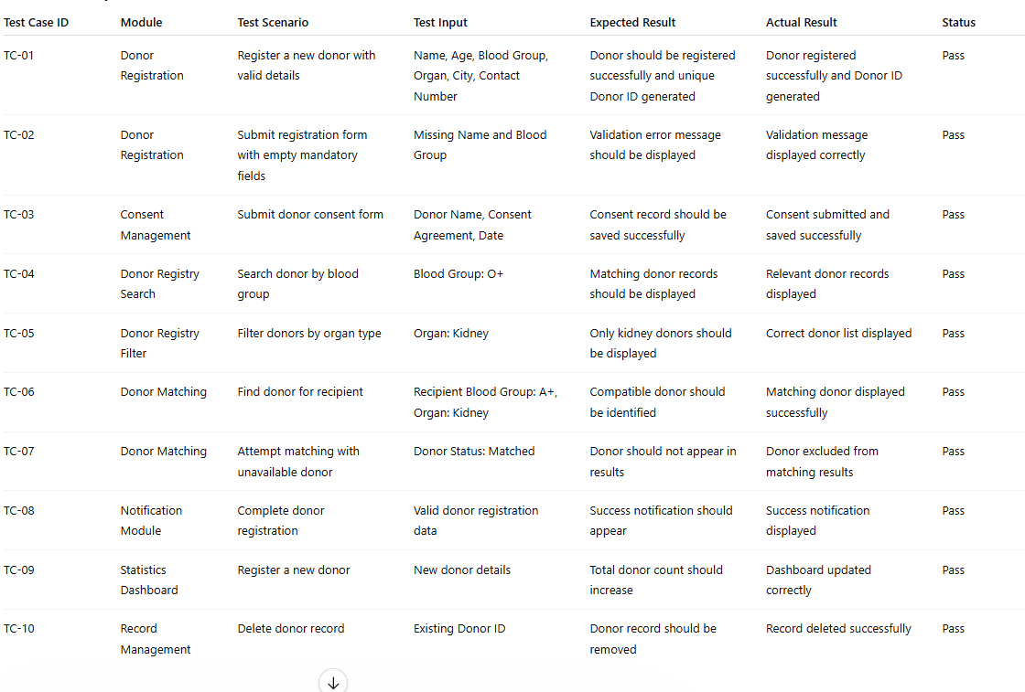

CHAPTER -9 DEPLOYMENT

9.1 Steps to Deploy

Deployment is the process of making the GiveLife – Organ Donor Registry Portal available to end users through the internet. It is one of the most important phases in the software development life cycle because it transforms the developed application into a fully functional system that can be accessed and utilized by users. A successful deployment process ensures that the application performs efficiently, remains secure, and provides a smooth user experience. For the GiveLife Portal, deployment involves preparing the application files, configuring the required environment, selecting suitable hosting services, and verifying that all functionalities work correctly after publication.

The deployment process begins with the completion of software development and testing activities. Before deploying the application, all modules such as Donor Registration, Consent Management, Donor Registry, Donor Matching, Notification System, and Statistics Dashboard must be fully implemented and tested. Functional testing, integration testing, and performance testing are performed to identify and fix bugs. This ensures that the application is stable and ready for production use.

The second step involves organizing project resources and source code. All HTML, CSS, JavaScript, images, icons, configuration files, and supporting assets are structured properly within the project directory. Developers remove unused files, debugging code, and temporary resources to improve maintainability and reduce deployment size. Proper project organization simplifies future updates and maintenance activities.

The third step is source code management using Git and GitHub. The complete project is uploaded to a GitHub repository. Version control systems help maintain project history, track modifications, and enable collaboration among team members. GitHub also acts as a central platform for integrating with deployment services such as Netlify, Vercel, and GitHub Pages.

The fourth step involves configuring production settings. Environment variables, API endpoints, database connection strings, security credentials, and authentication settings are configured according to production requirements. These configurations ensure that the application communicates properly with backend services and external systems.

The fifth step is application optimization. Developers perform code minification, image compression, file bundling, and caching optimization to improve loading speed and performance. Optimized applications consume fewer resources and provide a better user experience.

The sixth step is frontend deployment. Since the GiveLife Portal uses HTML, CSS, and JavaScript, the frontend can be deployed using platforms such as Netlify, Vercel, Firebase Hosting, or GitHub Pages. These services provide automatic deployment, secure HTTPS access, custom domains, and high availability.

If a backend service is used, the seventh step involves backend deployment. Platforms such as Render, Railway, AWS, Azure, and Heroku can host backend services, APIs, authentication modules, and databases. Backend deployment ensures proper handling of donor information, matching operations, and administrative functionalities.

After deployment, verification testing is performed in the production environment. Developers test donor registration, consent submission, donor search, matching operations, notifications, and dashboard statistics to ensure that all functionalities operate correctly. Monitoring tools are used to observe application performance and identify any issues.

Security is another critical aspect of deployment. HTTPS encryption, access control mechanisms, secure API communication, and authentication systems are configured to protect sensitive donor information. Regular security updates and monitoring help safeguard the system from cyber threats.

Continuous Integration and Continuous Deployment (CI/CD) practices may also be implemented. Tools such as Jenkins automatically build, test, and deploy updated versions whenever code changes are made. This improves development efficiency and reduces deployment errors.

In conclusion, deployment is a structured process that transforms the GiveLife – Organ Donor Registry Portal into a live, accessible, and reliable application. By following proper deployment procedures, the portal can effectively support organ donor management activities while ensuring security, performance, and scalability.

9.2 Environment Configuration

Environment configuration refers to the setup of software tools, development frameworks, libraries, databases, hosting services, and security settings required to run the GiveLife – Organ Donor Registry Portal successfully. A properly configured environment ensures consistency across development, testing, and production stages and contributes significantly to system reliability, performance, and security.

The frontend environment consists primarily of HTML, CSS, and JavaScript technologies. HTML is responsible for structuring web pages, CSS is used for designing user interfaces, and JavaScript provides dynamic functionality. These technologies work together to create an interactive and responsive portal for donor registration, consent management, and donor matching operations.

Visual Studio Code is commonly used as the primary development environment. It provides advanced features such as syntax highlighting, debugging tools, integrated terminal support, version control integration, and extension management. These capabilities help developers write, test, and maintain code efficiently.

Version control configuration is established using Git and GitHub. Git tracks modifications to project files, while GitHub hosts repositories and facilitates collaboration among developers. Branching, merging, and pull request workflows support efficient project management and code maintenance.

For backend development, Node.js and Express.js may be configured to handle server-side operations. These technologies process user requests, manage donor data, execute matching algorithms, and communicate with databases. Backend services provide business logic and ensure secure data handling throughout the application.

Database configuration is another essential component. Databases such as MongoDB Atlas or PostgreSQL can be configured to store donor information, consent records, matching results, and administrative data. Database credentials, access permissions, and connection strings are secured through environment variables to prevent unauthorized access.

Security configuration is a major aspect of environment setup. HTTPS encryption is enabled to protect data transmitted between users and the application. Authentication and authorization mechanisms restrict system access to authorized users. Input validation, data sanitization, and secure session management help prevent attacks such as SQL injection, cross-site scripting, and unauthorized data access.

Hosting platform configuration is also required. Platforms such as Netlify, Vercel, AWS, Render, and Azure require build commands, deployment settings, SSL certificates, domain configurations, and environment variables. Proper configuration ensures seamless deployment and reliable application performance.

Performance optimization settings improve user experience and resource utilization. Caching strategies, content delivery networks (CDNs), image optimization techniques, and file compression reduce loading times and improve responsiveness. Monitoring tools may also be configured to track application health and identify performance bottlenecks.

Backup and recovery configurations are important for protecting donor information. Automated database backups, disaster recovery plans, and versioned storage systems ensure that critical data can be restored in the event of failures.

Continuous Integration and Continuous Deployment environments may also be configured using Jenkins and GitHub Actions. These tools automate building, testing, and deployment activities, reducing manual effort and improving software quality.

Overall, environment configuration establishes the foundation required for the successful operation of the GiveLife – Organ Donor Registry Portal. Proper configuration ensures security, reliability, scalability, maintainability, and efficient system performance while supporting future growth and enhancements.

9.3 Hosting of Frontend and Backend
Hosting is one of the most important phases in the deployment process because it makes the application accessible to users through the internet. For the GiveLife – Organ Donor Registry Portal, hosting involves deploying both the frontend and backend components on reliable platforms that provide storage, processing power, networking services, and security features. Proper hosting ensures that the portal remains available, secure, scalable, and efficient for all users. It allows donors, administrators, and healthcare professionals to access the system anytime and from any location.

The frontend of the GiveLife Portal is developed using HTML, CSS, and JavaScript. These technologies generate the user interface through which users interact with the system. The frontend contains pages for donor registration, consent submission, donor search, donor matching, dashboard statistics, and notifications. Since these files are static in nature, they can be hosted using platforms such as Netlify, Vercel, GitHub Pages, or Firebase Hosting.

These platforms are specifically designed for hosting web applications and provide fast content delivery, automatic deployment, HTTPS security, and custom domain support.
The frontend hosting process begins by uploading the source code to a GitHub repository. The hosting platform is then connected to the repository. Whenever developers push updates to GitHub, the hosting platform automatically detects the changes, rebuilds the application, and deploys the latest version. This process is known as Continuous Deployment and helps ensure that users always access the most recent version of the application. Automatic deployment also reduces manual effort and minimizes deployment errors.

One of the major advantages of frontend hosting platforms is the use of Content Delivery Networks (CDNs). A CDN stores copies of the application across multiple servers located in different geographical regions. When a user accesses the GiveLife Portal, the content is delivered from the nearest server, resulting in faster loading times and improved performance. This significantly enhances user experience and reduces latency.
If the application includes server-side functionality, backend hosting becomes essential. The backend is responsible for handling business logic, authentication, donor matching algorithms, notifications, and communication with databases. Backend services can be hosted on cloud platforms such as Render, Railway, Heroku, Amazon Web Services (AWS), Microsoft Azure, and Google Cloud Platform (GCP). These platforms provide scalable infrastructure capable of handling large numbers of requests efficiently.

The backend receives requests from the frontend through APIs. For example, when a donor submits a registration form, the frontend sends the information to the backend server. The backend validates the information, processes it, stores it in the database, and sends a response back to the frontend. Similar interactions occur during donor matching, consent submission, record updates, and administrative operations. Proper backend hosting ensures that these processes are executed quickly and reliably.

Database hosting is another critical aspect of the system architecture. The GiveLife Portal may use cloud database services such as MongoDB Atlas or PostgreSQL for storing donor records, consent forms, matching information, and administrative data. These cloud databases provide centralized storage that can be accessed securely from different locations. They also offer automated backups, data replication, disaster recovery mechanisms, and performance monitoring features.

Security is a major consideration in hosting because the portal manages sensitive donor information. HTTPS encryption is enabled to protect data transmitted between users and the server. SSL certificates ensure secure communication and prevent unauthorized interception of information. Authentication and authorization mechanisms restrict access to authorized users only. Firewalls, intrusion detection systems, and security monitoring tools further strengthen the protection of donor data.

Scalability is another important advantage of cloud hosting. As the number of registered donors and system users increases, additional computing resources can be allocated automatically. This ensures that the portal continues to operate efficiently even during periods of high traffic. Cloud platforms provide flexible resource management, allowing organizations to scale their infrastructure according to demand.

Reliability and availability are also enhanced through cloud hosting services. Most hosting providers offer uptime guarantees, load balancing, and redundant infrastructure to minimize service interruptions. Regular backups ensure that donor information can be recovered in case of hardware failures or accidental data loss. Monitoring tools continuously track system health and generate alerts whenever issues are detected.

Maintenance activities are performed periodically after deployment. Software updates, security patches, performance optimizations, and database maintenance help ensure smooth operation of the system. Hosting platforms provide dashboards that allow administrators to monitor resource utilization, traffic patterns, response times, and error logs. These insights help identify potential problems and improve overall system performance.

Another important aspect of hosting is domain management. A custom domain name such as www.givelifeportal.com can be associated with the hosted application. Custom domains improve professionalism, branding, and user accessibility. Hosting providers typically offer easy domain integration along with DNS management services.

In conclusion, hosting plays a crucial role in the successful operation of the GiveLife – Organ Donor Registry Portal. By deploying the frontend, backend, and database components on reliable cloud platforms, the application becomes accessible, secure, scalable, and highly available. Effective hosting ensures smooth communication between system components, protects sensitive donor information, improves user experience, and provides a strong foundation for future growth and development. This makes hosting an essential component in delivering a dependable and efficient organ donor management system.

Frontend Hosting
Frontend hosting refers to the process of deploying and making the user interface of the GiveLife – Organ Donor Registry Portal accessible over the internet. The frontend is developed using HTML, CSS, and JavaScript and contains all the pages that users interact with, including the Home Page, Donor Registration Form, Consent Management Page, Donor Registry, Donor Matching Module, and Statistics Dashboard. Frontend hosting ensures that users can access these pages through a web browser from any location.

The frontend application consists of static files such as HTML documents, CSS stylesheets, JavaScript files, images, icons, and other user interface resources. These files are uploaded to hosting platforms such as Netlify, Vercel, GitHub Pages, or Firebase Hosting. These platforms are specifically designed for hosting web applications and provide fast, reliable, and secure access to users.

The hosting process begins by uploading the project source code to a GitHub repository. The frontend hosting platform is then connected to the repository. Whenever developers make changes and push updates to GitHub, the hosting platform automatically rebuilds and deploys the latest version of the application. This automated deployment process ensures that the live website always reflects the most recent version of the project.

One of the major advantages of frontend hosting is the use of Content Delivery Networks (CDNs). CDNs store copies of the website on multiple servers located around the world. When users access the GiveLife Portal, the website content is delivered from the nearest server, reducing loading times and improving performance. This enhances user experience and ensures fast access regardless of the user's geographical location.

Frontend hosting platforms also provide HTTPS security through SSL certificates. HTTPS encrypts communication between users and the application, protecting sensitive donor information from unauthorized access. Additional features such as custom domains, automatic backups, performance optimization, and monitoring services further improve the reliability of the hosted application.

Overall, frontend hosting ensures that the user interface of the GiveLife – Organ Donor Registry Portal is available, secure, responsive, and accessible to users at all times. It plays a critical role in delivering a smooth and user-friendly experience for donors, administrators, and healthcare professionals.

9.3.2 Backend Hosting
Backend hosting refers to the deployment of server-side components that manage application logic, data processing, authentication, donor matching, notifications, and database communication. While the frontend handles user interactions, the backend performs all processing activities behind the scenes. Backend hosting ensures that these operations are executed efficiently and securely whenever users interact with the GiveLife – Organ Donor Registry Portal.

The backend may be developed using technologies such as Node.js and Express.js. It processes requests received from the frontend, validates user inputs, applies business logic, communicates with the database, and returns appropriate responses. For example, when a donor submits a registration form, the backend receives the data, verifies its validity, stores it in the database, and sends a confirmation response back to the frontend.

Backend services are hosted on cloud platforms such as Render, Railway, Heroku, Amazon Web Services (AWS), Microsoft Azure, or Google Cloud Platform (GCP). These platforms provide computing resources, networking services, storage systems, and security features required to run server-side applications. They also offer scalability, allowing the application to handle increasing numbers of users and requests without performance degradation.

Database hosting is an important part of backend infrastructure. Cloud databases such as MongoDB Atlas or PostgreSQL store donor information, consent records, donor matching data, and administrative information. The backend communicates with these databases through secure connections to retrieve, update, and manage information whenever required.

Security is a major focus of backend hosting. Authentication and authorization mechanisms ensure that only authorized users can access specific functionalities. HTTPS encryption protects data transmission, while firewalls and security monitoring systems help prevent cyberattacks. Environment variables are used to store sensitive information such as database credentials and API keys securely.

Backend hosting platforms also provide features such as automatic scaling, load balancing, backup management, logging, and monitoring. These features help maintain system reliability and availability. Monitoring tools continuously track server performance, memory usage, response times, and error rates, allowing administrators to identify and resolve issues quickly.
In the GiveLife – Organ Donor Registry Portal, backend hosting supports critical functionalities such as donor registration processing, consent management, donor matching algorithms, notification generation, and database operations. Without backend hosting, the application would not be able to store donor records, perform matching operations, or manage user data effectively.

Therefore, backend hosting forms the core operational layer of the GiveLife Portal, ensuring secure data management, reliable processing, and efficient communication between the frontend and database systems. It enables the portal to function as a complete and dependable organ donor management solution

CI/CD Integration
CI/CD (Continuous Integration and Continuous Deployment) is a modern software development practice that automates the process of building, testing, and deploying applications. In the GiveLife – Organ Donor Registry Portal, CI/CD helps ensure that new code changes are integrated, tested, and deployed efficiently without affecting the existing functionality of the system.

Continuous Integration (CI) allows developers to regularly upload code changes to a shared GitHub repository. Whenever new code is pushed, automated testing tools verify that all modules, such as Donor Registration, Consent Management, Donor Matching, and Notification Systems, continue to function correctly. This helps identify and fix errors early in the development process.

Continuous Deployment (CD) automatically deploys the tested application to hosting platforms such as Netlify, Vercel, or Render. This eliminates manual deployment steps and ensures that users always access the latest version of the portal. Tools such as Jenkins and GitHub Actions can be used to automate the entire workflow.

CI/CD integration improves software quality, reduces deployment time, minimizes human errors, and supports faster delivery of updates and new features. It also enhances collaboration among developers by maintaining a consistent and reliable development environment. Overall, CI/CD plays a vital role in ensuring the stability, reliability, and continuous improvement of the GiveLife – Organ Donor Registry Portal.

Monitoring and Performance Optimisation
Monitoring and Performance Optimisation are essential activities performed after deploying the GiveLife – Organ Donor Registry Portal. Monitoring involves continuously observing the application's performance, availability, and security to ensure that it functions correctly for users. It helps identify issues such as slow response times, server errors, system failures, and security threats before they affect the user experience.

Various monitoring tools can be used to track important metrics such as website uptime, page load speed, API response time, database performance, and resource utilization. These metrics help administrators understand how the system is performing and identify areas that require improvement. Error logs and activity reports are also analyzed regularly to detect and resolve issues quickly.

Performance optimisation focuses on improving the speed, efficiency, and responsiveness of the application. Techniques such as image compression, code minification, browser caching, and Content Delivery Networks (CDNs) are used to reduce loading times. Database queries are optimized to improve data retrieval speed, while unnecessary scripts and resources are removed to enhance overall performance.

For the GiveLife Portal, performance optimisation ensures that donor registration, consent management, donor searching, and donor matching operations execute quickly and efficiently. Regular monitoring and optimisation improve user satisfaction, reduce downtime, enhance reliability, and ensure that the application continues to perform effectively as the number of users and donor records increases. These practices contribute significantly to the long-term success and scalability of the system.

Domain, Networking, and Global Access
Domain, Networking, and Global Access are important components of the deployment process that ensure the GiveLife – Organ Donor Registry Portal is accessible, secure, and available to users worldwide. A domain name provides a unique and easy-to-remember web address that allows users to access the application without needing to remember complex server IP addresses. For example, the portal can be hosted using a custom domain such as www.givelifeportal.com, which improves professionalism, branding, and user trust.

Networking refers to the communication infrastructure that enables data exchange between users, servers, databases, and application services. When a user accesses the GiveLife Portal, requests are transmitted through the internet to the hosting server, where they are processed and returned with the required information. Proper network configuration ensures fast, reliable, and secure communication between all system components.

To enhance security, HTTPS protocol and SSL certificates are implemented. These technologies encrypt data transmitted between users and the portal, protecting sensitive donor information from unauthorized access. Firewalls, access controls, and secure API communication further strengthen network security.

Global access is achieved through cloud hosting platforms and Content Delivery Networks (CDNs). CDNs distribute website content across multiple servers located in different geographic regions. When users access the portal, content is delivered from the nearest server, reducing latency and improving loading speed. This ensures a consistent user experience regardless of location.

Domain management, secure networking, and global accessibility help the GiveLife – Organ Donor Registry Portal remain reliable, scalable, and accessible to donors, administrators, and healthcare professionals worldwide. These technologies support continuous availability and efficient system performance while enabling future expansion to serve a larger user base.

Scaling, Backup, and Redundancy
Scaling, Backup, and Redundancy are essential aspects of maintaining the GiveLife – Organ Donor Registry Portal after deployment. These practices ensure that the system remains available, reliable, and capable of handling increasing numbers of users and donor records without performance issues.

Scaling refers to the ability of the application to accommodate growth in user traffic and data volume. As more donors register and more healthcare professionals use the portal, the system must continue to perform efficiently. Cloud hosting platforms such as AWS, Azure, Render, and Google Cloud provide scalable infrastructure that can automatically allocate additional computing resources when demand increases. This ensures that donor registration, consent management, donor matching, and search operations remain fast and responsive even during peak usage periods.

Backup is the process of creating copies of important data and system resources to prevent data loss. In the GiveLife Portal, donor information, consent records, matching details, and administrative data are critical assets. Regular automated backups are performed and stored securely in cloud storage systems. If data is accidentally deleted, corrupted, or affected by hardware failures, backups can be restored quickly to recover the lost information. Backup strategies help ensure data integrity and business continuity.
Redundancy refers to maintaining duplicate systems, servers, or databases that can take over if a primary component fails. Redundant infrastructure minimizes downtime and ensures continuous system availability. For example, multiple servers may host copies of the application, while replicated databases maintain duplicate donor records in separate locations. If one server or database becomes unavailable, another backup system automatically continues operations without disrupting users.

Together, scaling, backup, and redundancy improve the reliability, availability, and fault tolerance of the GiveLife – Organ Donor Registry Portal. These mechanisms ensure uninterrupted service, protect valuable donor information, and support future expansion of the system as the number of users and organ donation activities continues to grow.

Post-Deployment Verification and Maintenance
Post-Deployment Verification and Maintenance are important activities performed after the GiveLife – Organ Donor Registry Portal has been successfully deployed. The purpose of post-deployment verification is to ensure that the application functions correctly in the live environment and that all features are operating as expected. Maintenance activities help keep the system secure, reliable, and up to date over time.

After deployment, a series of verification tests are conducted to confirm that all modules of the portal are working properly. Key functionalities such as Donor Registration, Consent Management, Donor Registry, Donor Matching, Notifications, and Statistics Dashboard are tested in the production environment. Developers verify that users can access the portal, submit donor information, search records, perform matching operations, and receive appropriate notifications without errors. Any issues identified during verification are immediately corrected to ensure smooth system operation.

Maintenance is a continuous process that involves monitoring, updating, and improving the application after deployment. Regular software updates are performed to fix bugs, improve performance, and introduce new features. Security patches are applied to protect the system from vulnerabilities and cyber threats. Database maintenance activities such as backup verification, data cleanup, and performance optimization are also carried out periodically.

System administrators continuously monitor server performance, resource utilization, response times, and error logs to identify potential problems. Monitoring tools help detect issues early and prevent service interruptions. User feedback is also collected and analyzed to identify areas for improvement and enhance the overall user experience.

In addition, regular backups are maintained to ensure data recovery in case of system failures or accidental data loss. Disaster recovery procedures are tested periodically to ensure business continuity. Documentation is updated whenever changes are made to the system, helping future maintenance and development activities.

CHAPTER -10 CHALLENGES & LIMITATIONS

10.1 Issues Faced During Development

The development of the GiveLife – Organ Donor Registry Portal involved several challenges that required careful planning, problem-solving, and continuous testing. Although the project was successfully completed, various technical, functional, and design-related issues were encountered during different stages of development. Overcoming these challenges helped improve the overall quality, reliability, and usability of the system.

One of the major challenges faced during development was designing an intuitive and user-friendly interface. Since the portal is intended for a wide range of users, including donors, administrators, and healthcare professionals, the interface needed to be simple, responsive, and easy to navigate. Creating forms, dashboards, tables, and interactive components while maintaining a clean design required significant effort and multiple revisions.

Another challenge was implementing proper form validation. The donor registration and consent forms contain several mandatory fields such as donor name, age, blood group, contact information, and organ selection. Ensuring that users entered valid information and preventing incorrect or incomplete submissions required extensive validation logic. Different validation scenarios had to be tested to ensure data accuracy and reliability.

Developing the donor matching functionality was also a significant challenge. The system needed to identify compatible donors based on blood group compatibility and organ availability. Implementing matching rules correctly while ensuring accurate results required careful analysis and testing. Various matching scenarios were evaluated to confirm that the system produced reliable recommendations.

Managing donor information through Local Storage and data persistence mechanisms presented additional difficulties. The application needed to store donor records, consent information, and matching results while maintaining consistency across different modules. Ensuring proper data retrieval, updates, and deletion operations required careful coding and debugging.

Another issue involved module integration and synchronization. Different modules such as Donor Registration, Donor Registry, Donor Matching, Notification System, and Statistics Dashboard needed to communicate effectively. Ensuring that updates made in one module were immediately reflected in other related modules required extensive integration testing and troubleshooting.

The implementation of real-time notifications and dashboard statistics also presented challenges. The notification system needed to display accurate success and error messages after every important operation, while the statistics dashboard had to update dynamically whenever donor records changed. Synchronizing these features with the underlying data required additional development effort.

Cross-browser compatibility was another challenge encountered during development. The application needed to function consistently across browsers such as Google Chrome, Microsoft Edge, and Mozilla Firefox. Differences in browser rendering behavior occasionally affected layouts and functionality, requiring additional testing and adjustments.
Debugging JavaScript code was a frequent challenge throughout the development process. Issues such as incorrect data handling, event management problems, and user interface inconsistencies required continuous troubleshooting using browser developer tools. Careful debugging and testing were necessary to resolve these problems effectively.

Performance optimization also required attention. As donor records increased, search operations, filtering processes, and dashboard updates needed to remain responsive. Various optimization techniques were applied to improve system performance and maintain a smooth user experience.
Finally, ensuring the overall reliability and security of the system was a continuous challenge. Sensitive donor information needed to be handled responsibly, and proper validation mechanisms were implemented to reduce the risk of incorrect data entry and unauthorized access.

Despite these challenges, systematic planning, continuous testing, and iterative improvements enabled the successful development of the GiveLife – Organ Donor Registry Portal. The experience gained while addressing these issues contributed significantly to the project's success and provided valuable insights into modern web application development practices.

10.2 Solutions Applied
During the development of the GiveLife – Organ Donor Registry Portal, several technical and functional challenges were encountered. To ensure the successful completion of the project, appropriate solutions were implemented to address these issues. These solutions improved system performance, usability, reliability, and overall functionality.
One of the primary challenges was creating a user-friendly and responsive interface. To address this issue, a structured design approach was adopted using HTML, CSS, and JavaScript. Responsive layouts, clear navigation menus, and properly organized forms were implemented to improve usability. Multiple design revisions and user interface testing sessions were conducted to ensure that users could easily access and operate the portal.

To overcome problems related to invalid or incomplete data entry, comprehensive form validation mechanisms were implemented. JavaScript validation functions were used to verify donor details such as age, blood group, contact information, and organ selection before form submission. Mandatory field checks and input restrictions helped maintain data accuracy and reduce the possibility of incorrect records being stored in the system.

The donor matching module presented challenges in identifying compatible donors accurately. To solve this problem, a well-defined matching algorithm based on blood group compatibility rules and organ availability was developed. Extensive testing was performed using different donor and recipient scenarios to verify the accuracy of the matching results. This ensured that the system could provide reliable donor recommendations.

Data management issues were resolved through the effective use of Local Storage. Structured data storage techniques were implemented to store donor records, consent information, and matching details. Functions were developed to retrieve, update, and delete records efficiently while maintaining consistency across all modules of the application.
To address integration challenges between different modules, a centralized data management approach was adopted. All modules were designed to access and update shared data consistently. Integration testing was performed regularly to verify that changes made in one module were reflected correctly in other related modules. This improved communication between the Donor Registration, Donor Registry, Donor Matching, and Dashboard modules.

For real-time user feedback, a notification system was implemented using dynamic JavaScript functions. Toast notifications were introduced to display success messages, warnings, and error alerts whenever users performed important actions such as registration, consent submission, matching, or record deletion. This improved user interaction and system transparency.
The challenge of maintaining accurate dashboard statistics was addressed by implementing automatic data synchronization techniques. Dashboard counters were programmed to update dynamically whenever donor records were added, modified, matched, or removed. This ensured that statistical information remained accurate and up to date at all times.

Cross-browser compatibility issues were resolved through extensive testing on multiple web browsers including Google Chrome, Mozilla Firefox, and Microsoft Edge. Browser-specific inconsistencies were identified and corrected using standard web development practices and compatibility testing tools.

Performance-related issues were minimized through code optimization techniques. Unnecessary computations were reduced, efficient search algorithms were implemented, and data handling functions were optimized to improve responsiveness. These improvements ensured smooth operation even when managing larger numbers of donor records.

Security concerns were addressed through proper input validation, secure coding practices, and controlled access to sensitive donor information. Validation checks helped prevent invalid data entry and improved overall system integrity.
Finally, continuous testing and debugging played a crucial role in solving development challenges. Tools such as browser developer tools, Postman, Selenium, and manual testing techniques were used to identify and fix errors throughout the development process. Regular testing ensured that all modules functioned correctly and met the project requirements.
Overall, the solutions applied during development significantly improved the quality, reliability, and efficiency of the GiveLife – Organ Donor Registry Portal, enabling it to successfully achieve its objectives and provide an effective platform for organ donor management.

10. 3 Current Limitations or Known Bugs

Despite the successful implementation of the GiveLife – Organ Donor Registry Portal, certain limitations and known issues exist in the current version of the system. These limitations are common in academic and prototype-level projects and provide opportunities for future enhancements. While the portal effectively performs donor registration, consent management, donor searching, and donor matching, some advanced functionalities that would be required in a real-world healthcare environment are not yet fully implemented.

One of the primary limitations of the current system is the use of browser-based Local Storage for storing donor information. Local Storage provides a simple and effective way to save data during development; however, it is not suitable for large-scale deployment. Data stored in Local Storage remains available only on the specific device and browser where it was entered. If users switch devices, reinstall the browser, or clear browser data, all stored records may be lost. A cloud-based database such as MongoDB Atlas or PostgreSQL would provide better reliability, scalability, and centralized access.

Another limitation is the absence of a centralized multi-user environment. Currently, donor information is managed locally, meaning multiple hospitals, administrators, or healthcare organizations cannot access and update the same donor database simultaneously. In a real-world organ donation network, centralized access and real-time synchronization between different medical institutions are essential requirements.

The donor matching module currently uses basic blood group compatibility rules and organ availability to identify suitable donors. While this provides a useful demonstration of the matching process, actual organ transplantation requires consideration of several additional medical parameters. Factors such as tissue compatibility, HLA matching, medical history, donor health conditions, recipient urgency level, geographic distance, and organ preservation time are not included in the current version. As a result, the matching process is simplified compared to real healthcare systems.

The system also has limited authentication and authorization capabilities. Although administrative functions can be demonstrated, a complete user management system with secure login, password encryption, multi-factor authentication, and role-based access control has not been fully implemented. This limitation may affect the security and privacy of sensitive donor information in a production environment.
Another known limitation is the lack of integration with government healthcare systems, hospitals, and transplant organizations. The current portal operates as an independent application and does not communicate with external medical databases or healthcare networks. Integration with national health systems would improve donor verification, record accuracy, and transplant coordination.

The notification module currently provides only browser-based notifications and alerts. While these notifications effectively inform users about registration success, matching results, and record updates, the system does not support email notifications, SMS alerts, or mobile push notifications. Such communication features would be valuable in real-life situations where immediate donor-recipient coordination is required.
The application also lacks advanced data analytics and reporting capabilities. The dashboard currently displays basic statistics such as total donors, available donors, and matched donors. However, healthcare administrators may require detailed reports, trend analysis, graphical visualizations, and predictive analytics to support decision-making and planning activities.

Another limitation is related to scalability and performance. Since the application primarily relies on client-side processing, performance may decrease if a very large number of donor records are stored and processed. Search operations, filtering functions, and dashboard updates may become slower as the dataset grows significantly. A server-based architecture with optimized database queries would improve performance in large-scale environments.
Cross-browser compatibility has been tested on major browsers such as Google Chrome, Mozilla Firefox, and Microsoft Edge. However, minor display inconsistencies may occur on older browsers or unsupported devices. Differences in browser rendering engines can occasionally affect page layouts, table formatting, or user interface components.

The system currently supports only English-language content. Users who speak other languages may find it difficult to use the application effectively. Future versions can include multilingual support to improve accessibility and serve a broader user population.
Mobile responsiveness has been implemented for common screen sizes; however, certain complex tables and dashboard components may not display optimally on very small mobile devices. Additional responsive design improvements can further enhance the mobile user experience.

The current version also lacks offline backup and disaster recovery mechanisms. Although data can be stored locally, there are limited recovery options if accidental deletion or hardware failure occurs. Automated cloud backups and recovery procedures would significantly improve system reliability.

From a security perspective, the application uses input validation and basic protection mechanisms, but advanced security features such as intrusion detection systems, audit logging, activity tracking, and encryption of stored donor data are not fully implemented. These features are important for protecting sensitive healthcare information in real-world deployments.
Some minor bugs may occasionally occur during rapid consecutive operations such as repeated donor registration, simultaneous record updates, or multiple matching attempts. While these issues do not significantly affect overall functionality, additional testing and optimization would further improve system stability.

In conclusion, the GiveLife – Organ Donor Registry Portal successfully demonstrates the core functionalities required for organ donor management. However, limitations related to data storage, security, scalability, centralized access, advanced donor matching, communication services, and healthcare integration still exist. Addressing these limitations in future versions will significantly enhance the system's effectiveness, reliability, and suitability for real-world healthcare applications. The identified limitations provide valuable opportunities for future research, development, and system improvement.

CHAPTER -11 FUTURE ENHANCEMENTS

11.1 Planned Features
The current version of the GiveLife – Organ Donor Registry Portal successfully provides essential functionalities such as donor registration, consent management, donor matching, donor search, and donor record management. However, to further improve the effectiveness, usability, and scalability of the system, several advanced features are planned for future development. These enhancements aim to transform the portal into a more comprehensive and real-world organ donation management platform.
One of the most important planned features is the implementation of a centralized cloud-based database. The current system uses browser-based Local Storage for data management, which limits accessibility and scalability. By integrating cloud databases such as MongoDB Atlas or PostgreSQL, donor information can be stored securely and accessed from multiple devices and locations. This enhancement will enable real-time data synchronization and improve data reliability.
Another planned feature is the introduction of a secure user authentication and authorization system. Future versions will include user registration, login functionality, password encryption, multi-factor authentication, and role-based access control. Different user roles such as donors, administrators, doctors, and hospital staff will have specific permissions based on their responsibilities. This will improve security and ensure controlled access to sensitive donor information.
The donor matching module will also be enhanced with advanced medical compatibility analysis. Instead of relying only on blood group compatibility, future versions will consider additional medical factors such as tissue matching, donor health conditions, recipient urgency levels, age compatibility, and geographical location. These improvements will make the matching process more accurate and suitable for real-world transplantation scenarios.
Integration with hospital management systems and government healthcare databases is another important future enhancement. Such integration will allow healthcare institutions to verify donor records, update transplantation information, and coordinate donation activities more efficiently. This feature will improve collaboration between different organizations involved in organ donation and transplantation.
The portal will also incorporate email notifications, SMS alerts, and mobile push notifications. These communication services will automatically inform donors, recipients, administrators, and healthcare professionals about important events such as successful registrations, consent approvals, donor matches, and appointment schedules. Real-time notifications will improve communication and reduce delays in critical situations.
Another planned feature is the development of a mobile application for Android and iOS devices. A dedicated mobile app will provide greater accessibility and convenience for users. Donors will be able to register, update their information, manage consent forms, and receive notifications directly through their smartphones. Mobile access will significantly increase user engagement and participation.
The future system will also include advanced analytics and reporting capabilities. Interactive dashboards, graphical reports, and statistical visualizations will help administrators monitor donor trends, organ availability, registration growth, and transplantation activities. These insights will support decision-making and strategic planning.
To improve accessibility, multi-language support will be introduced. Users will be able to access the portal in different regional and international languages, making the system more inclusive and user-friendly for diverse populations.
Artificial Intelligence (AI) and Machine Learning technologies may also be incorporated in future versions. AI-based donor matching algorithms can analyze large volumes of medical data and provide more accurate compatibility recommendations. Predictive analytics can help identify donation trends and optimize organ allocation processes.
Another planned enhancement is the implementation of blockchain technology for secure and transparent record management. Blockchain can provide tamper-proof storage of donor consent records and transplantation history, increasing trust and accountability within the system.
Future versions will also focus on improving system scalability, security, and performance through cloud computing, microservices architecture, automated backups, disaster recovery mechanisms, and advanced cybersecurity measures.
In conclusion, the planned features for the GiveLife – Organ Donor Registry Portal aim to enhance functionality, security, accessibility, and operational efficiency. These improvements will transform the portal from an academic project into a comprehensive, reliable, and scalable organ donation management system capable of supporting real-world healthcare and transplantation activities,
The GiveLife – Organ Donor Registry Portal can be significantly improved through the integration of advanced technologies and the implementation of various optimization techniques. These enhancements will increase the system's efficiency, reliability, security, scalability, and overall user experience. As organ donation management involves handling sensitive information and coordinating multiple stakeholders, future integrations can help transform the portal into a comprehensive healthcare solution.
One of the most valuable integrations is the connection of the portal with hospital management systems and healthcare databases. Such integration would allow hospitals to access donor information directly, verify donor eligibility, update transplantation records, and coordinate organ allocation processes more efficiently. Healthcare professionals would be able to retrieve accurate donor data in real time, reducing administrative workload and improving decision-making.
Another important integration involves linking the portal with government health registries and national organ donation networks. This would enable automatic verification of donor records, prevent duplicate registrations, and facilitate collaboration among healthcare institutions. Integration with official databases would improve the authenticity and reliability of donor information while supporting large-scale organ donation programs.
The notification system can be optimized through integration with email services, SMS gateways, and mobile push notification platforms. Currently, notifications are limited to browser-based alerts. Future integrations with services such as Twilio, Firebase Cloud Messaging, or SendGrid would allow real-time communication with donors, recipients, doctors, and administrators. This would ensure timely updates regarding donor registrations, consent approvals, matching results, and transplantation procedures.
Another possible enhancement is the integration of Artificial Intelligence (AI) and Machine Learning technologies. AI-powered donor matching algorithms can analyze medical compatibility factors beyond blood groups, including tissue matching, health conditions, recipient urgency, and geographic location. Machine learning models can also identify donation trends, predict organ demand, and support better resource allocation decisions.
Cloud computing integration represents another major optimization opportunity. Migrating the system from Local Storage to cloud-based platforms such as MongoDB Atlas, AWS, Azure, or Google Cloud would improve data accessibility, scalability, backup management, and reliability. Cloud services provide centralized data storage, automatic backups, and disaster recovery capabilities, making the system more suitable for real-world healthcare environments.
The portal can also benefit from the implementation of RESTful APIs and third-party healthcare services. APIs would allow different systems to communicate seamlessly, enabling data exchange between hospitals, laboratories, healthcare organizations, and government agencies. This integration would improve interoperability and reduce manual data entry.
Performance optimization is another important area for future improvement. Techniques such as database indexing, caching mechanisms, code minification, image compression, and Content Delivery Networks (CDNs) can reduce loading times and improve system responsiveness. These optimizations ensure that the portal performs efficiently even when handling large volumes of donor records and user requests.
Security enhancements can also be implemented through integrations with advanced authentication systems. Features such as multi-factor authentication, biometric verification, encrypted data storage, audit logging, and security monitoring tools can strengthen data protection and prevent unauthorized access. These measures are particularly important because the portal manages sensitive personal and medical information.

Mobile application integration is another potential enhancement. Developing Android and iOS applications would provide users with convenient access to donor registration, consent management, notifications, and donor information through smartphones. Mobile accessibility can significantly increase user participation and engagement.
Another optimization involves implementing real-time analytics and business intelligence dashboards. Advanced reporting tools can generate graphical reports, donor statistics, transplantation trends, and performance metrics. These insights would help healthcare administrators make informed decisions and improve operational efficiency.
Future versions may also incorporate blockchain technology for secure and transparent record management. Blockchain can provide tamper-resistant storage of donor consent records and transplantation history, increasing trust, accountability, and data integrity within the system.
In conclusion, integrating advanced healthcare systems, cloud technologies, AI-based matching algorithms, communication services, mobile applications, and enhanced security mechanisms can greatly improve the GiveLife – Organ Donor Registry Portal. These optimizations will increase system performance, reliability, accessibility, and scalability while enabling the portal to support real-world organ donation and transplantation activities more effectively.

CHAPTER -12 CONCLUSION

12.1 Summary of the Project
The GiveLife – Organ Donor Registry Portal is a web-based application developed to provide an efficient, organized, and user-friendly platform for managing organ donor information and supporting the organ donation process. Organ donation plays a critical role in saving lives, but traditional donor management methods often involve manual record keeping, fragmented data storage, and time-consuming donor identification procedures. The GiveLife Portal was designed to address these challenges by creating a centralized system that simplifies donor registration, consent management, donor record maintenance, and donor-recipient matching.

The primary objective of the project was to develop a platform that allows individuals to register as organ donors and express their willingness to donate organs in a structured and legally compliant manner. The system provides a convenient method for collecting donor information such as personal details, blood group, organ preferences, contact information, and location details. By digitizing donor registration, the portal reduces paperwork, minimizes data entry errors, and improves record accessibility.

The project consists of several interconnected modules that work together to provide comprehensive organ donor management functionality. The Donor Registration Module enables users to submit their information through a simple and interactive form. The system validates user inputs and generates a unique donor identification number for every registered donor. This ensures that donor records remain organized and easily traceable.

The Consent Management Module was developed to address the legal and ethical aspects of organ donation. Through this module, donors can formally provide their consent and acknowledge their willingness to participate in organ donation programs. Maintaining proper consent records improves transparency and ensures compliance with ethical standards.

The Donor Registry and Search Module serves as a centralized repository where donor information can be stored, viewed, searched, and managed. Healthcare professionals and administrators can quickly locate donors using filters such as blood group, organ type, city, and availability status. This feature significantly improves operational efficiency and simplifies donor management activities.

One of the most significant features of the system is the Donor Matching Module. This module applies blood group compatibility rules and organ availability criteria to identify suitable donors for recipients. The matching process reduces the time required to locate compatible donors and supports faster decision-making in organ transplantation scenarios. Although simplified for the current implementation, the module demonstrates the importance of automated donor matching systems in healthcare environments.

The portal also includes a Notification System that provides real-time feedback whenever users perform important actions such as donor registration, consent submission, donor matching, or record deletion. Notifications improve user interaction and ensure that users receive immediate confirmation regarding system operations. Additionally, the Statistics Dashboard displays real-time information regarding total registered donors, available donors, and matched donors. These statistics provide valuable insights into system activity and help administrators monitor overall portal performance.

The development of the GiveLife Portal utilized modern web technologies including HTML, CSS, and JavaScript. HTML was used to structure web pages, CSS was applied to create responsive and visually appealing user interfaces, and JavaScript was employed to implement dynamic functionality and client-side logic. Local Storage was utilized for storing donor records and maintaining data persistence during application execution. Version control tools such as Git and GitHub were also used to manage source code and support collaborative development practices.

During development, several challenges were encountered, including form validation, donor matching logic, module integration, data synchronization, performance optimization, and user interface design. These challenges were addressed through systematic problem-solving approaches, extensive testing, and iterative improvements. Functional testing, integration testing, and user interface testing were performed to verify the correctness and reliability of all modules.
The project also covered important software engineering concepts such as deployment, environment configuration, frontend and backend hosting, CI/CD integration, monitoring, performance optimization, security considerations, backup management, and system maintenance. These aspects helped ensure that the application could be deployed and managed effectively in a production environment.

Although the current version successfully demonstrates the core functionalities of an organ donor management system, certain limitations remain. These include the use of Local Storage instead of a centralized database, simplified donor matching criteria, limited authentication features, and the absence of external healthcare system integrations. However, these limitations provide opportunities for future enhancements and further research.

Future improvements may include cloud database integration, hospital management system connectivity, advanced donor matching algorithms, AI-based decision support, mobile applications, real-time communication services, blockchain-based record management, and enhanced security mechanisms. These enhancements would increase scalability, improve reliability, and make the portal suitable for real-world healthcare deployment.

In conclusion, the GiveLife – Organ Donor Registry Portal successfully fulfills its objective of providing a centralized and efficient platform for organ donor management. The project demonstrates the practical application of web technologies in solving healthcare-related challenges and highlights the potential of digital solutions to improve organ donation processes. By streamlining donor registration, consent management, donor matching, and record administration, the portal contributes toward promoting organ donation awareness and supporting life-saving transplantation activities. The knowledge and experience gained during the development of this project provide a strong foundation for future innovation and advancement in healthcare information systems.

12.1 What Was Achieved
The development of the GiveLife – Organ Donor Registry Portal successfully achieved the primary objectives defined at the beginning of the project. The system was designed to provide a centralized, efficient, and user-friendly platform for managing organ donor information, and the final implementation successfully fulfills these goals. Through the integration of multiple functional modules, the project demonstrates how modern web technologies can be used to improve organ donor management processes and support healthcare-related services.

One of the major achievements of the project was the successful implementation of a digital donor registration system. The portal allows users to register as organ donors by providing personal information, blood group details, organ donation preferences, and contact information. The registration process is simple, efficient, and supported by input validation mechanisms that help maintain data accuracy. Each registered donor is assigned a unique donor identification number, making donor records easy to manage and track.

Another significant achievement was the development of the Consent Management Module. This module enables donors to provide formal consent for organ donation through a structured process. The system records donor consent information and maintains transparency regarding donor authorization. This feature demonstrates the importance of ethical and legal compliance within organ donation systems.

The project also successfully implemented a Donor Registry and Search System. All donor records can be stored, viewed, searched, filtered, and managed efficiently through a centralized interface. Users can search donors based on criteria such as blood group, organ type, city, and donor availability status. This achievement significantly improves the accessibility and organization of donor information.
One of the most important accomplishments of the project is the creation of the Donor Matching Module. The system applies blood group compatibility rules and organ availability criteria to identify suitable donors for recipients. This automated matching process reduces manual effort, speeds up donor identification, and demonstrates how technology can support life-saving medical procedures. Although simplified for academic purposes, the matching functionality successfully illustrates the concept of automated donor-recipient matching.
The implementation of a Notification System is another achievement of the project. Users receive immediate feedback whenever important actions are performed, such as donor registration, consent submission, donor matching, and record deletion. These notifications improve user interaction and ensure that system operations remain transparent and understandable.
The project also successfully developed a Statistics Dashboard that displays real-time information regarding total registered donors, available donors, and matched donors. This dashboard provides administrators with valuable insights into system activity and donor availability. The ability to monitor donor statistics contributes to better management and decision-making.

From a technical perspective, the project successfully utilized HTML, CSS, and JavaScript to create a responsive and interactive web application. The frontend provides an intuitive user interface, while JavaScript enables dynamic functionality such as validation, searching, filtering, matching, notifications, and dashboard updates. The project demonstrates effective use of modern web development technologies to build practical healthcare solutions.
Another achievement was the successful implementation of data management using Local Storage. Donor records, consent forms, and matching information can be stored and retrieved efficiently within the browser environment. Although future versions may adopt cloud databases, the current implementation successfully demonstrates data persistence and record management concepts.

The project also achieved successful testing and validation of all major functionalities. Functional testing, integration testing, and user interface testing confirmed that the system operates according to the specified requirements. Test results showed that donor registration, consent management, searching, filtering, matching, and notification features function correctly and reliably.

In addition, the project provided valuable practical experience in software engineering activities such as system analysis, requirement gathering, user interface design, coding, debugging, testing, deployment planning, version control, and documentation. These activities contributed to a better understanding of the complete software development life cycle.
Overall, the GiveLife – Organ Donor Registry Portal successfully achieved its intended objectives by creating a functional and reliable organ donor management platform. The project demonstrates the potential of digital technologies in improving healthcare services and establishes a strong foundation for future enhancements, large-scale deployment, and real-world organ donation management applications.

Skills Learned During Development

The development of the GiveLife – Organ Donor Registry Portal provided valuable learning opportunities and helped enhance both technical and professional skills. Throughout the project, various stages of the software development life cycle were explored, including requirement analysis, system design, coding, testing, deployment planning, documentation, and maintenance. Working on this project contributed significantly to improving knowledge of web development, problem-solving, project management, and software engineering practices.

One of the most important skills gained during the development process was frontend web development. The project involved extensive use of HTML, CSS, and JavaScript for creating interactive and responsive web pages. Through the development of donor registration forms, consent management pages, donor registry tables, and dashboard components, a deeper understanding of webpage structure, styling techniques, and dynamic user interactions was achieved. Knowledge of responsive web design principles was also improved, enabling the creation of interfaces that function effectively across different screen sizes and devices.

Another significant skill acquired was JavaScript programming. The project required implementing client-side functionality such as form validation, donor matching logic, search and filtering operations, notification systems, and dynamic dashboard updates. This helped strengthen programming skills, logical thinking abilities, and the understanding of event-driven web applications. Debugging JavaScript code also improved troubleshooting and analytical skills.

The project provided practical experience in data management and storage techniques. By using Local Storage to save donor records, consent information, and matching data, valuable insights were gained into data persistence, retrieval, updating, and deletion operations. Understanding how data flows between different modules improved overall software design and development knowledge.

Another important area of learning was system analysis and requirement gathering. Before development began, project objectives, user requirements, system functionalities, and technical specifications had to be carefully identified and documented. This process improved the ability to analyze problems, understand user needs, and design solutions that satisfy project requirements.

The implementation of the donor matching module enhanced algorithm design and problem-solving skills. Developing compatibility rules based on blood groups and organ availability required logical reasoning and structured thinking. Testing different scenarios helped improve the ability to design accurate and efficient solutions for real-world problems.
The project also strengthened user interface (UI) and user experience (UX) design skills. Considerable effort was invested in creating intuitive navigation, attractive layouts, and user-friendly forms. Learning how to design interfaces that improve accessibility and usability contributed to a better understanding of user-centered software development.

Another valuable skill gained was software testing and quality assurance. Functional testing, integration testing, and user interface testing were performed throughout the development process. Using tools such as Postman, Selenium, and browser developer tools helped improve the ability to identify, analyze, and resolve software defects. Testing activities also reinforced the importance of software reliability and quality control.

The project provided experience in version control and collaborative development practices through the use of Git and GitHub. Skills such as repository management, code versioning, branching, committing changes, and maintaining project history were developed. These skills are essential in modern software development environments where teamwork and code management play critical roles.

Knowledge of deployment concepts and hosting technologies was also gained during the project. Understanding frontend hosting, backend hosting, environment configuration, CI/CD integration, and cloud deployment practices provided valuable exposure to real-world software deployment processes. These concepts are important for ensuring that applications remain accessible, scalable, and reliable after development.

The project further improved documentation and technical writing skills. Preparing detailed project reports, system requirement documents, testing reports, deployment documentation, and user guides enhanced the ability to communicate technical information clearly and professionally. Proper documentation is an essential aspect of software engineering and contributes significantly to project success.
Time management and project planning skills were also developed throughout the project lifecycle. Managing different development phases, meeting deadlines, handling multiple tasks, and resolving unexpected challenges improved organizational abilities and professional discipline. Learning to prioritize tasks and allocate resources effectively contributed to successful project completion.

Additionally, the project strengthened critical thinking and problem-solving abilities. Various challenges such as form validation issues, module integration difficulties, data synchronization problems, and interface inconsistencies required systematic analysis and innovative solutions. Addressing these challenges improved confidence in handling complex technical problems.
Finally, the GiveLife – Organ Donor Registry Portal provided practical exposure to the complete Software Development Life Cycle (SDLC). From requirement analysis and system design to coding, testing, deployment, and maintenance, every stage contributed to a comprehensive understanding of software engineering principles and practices.

In conclusion, the development of the GiveLife – Organ Donor Registry Portal resulted in significant growth in technical knowledge, programming expertise, testing skills, deployment understanding, project management capabilities, and professional development. These skills not only contributed to the successful completion of the project but also provide a strong foundation for future software development and healthcare technology initiatives.

CHAPTER -13 REFERENCES

Books

Ian Sommerville, Software Engineering, 10th Edition, Pearson Education, 2016.
- Roger S. Pressman and Bruce R. Maxim, Software Engineering: A Practitioner's Approach, 9th Edition, McGraw-Hill Education, 2020.
- Thomas H. Cormen, Charles E. Leiserson, Ronald L. Rivest, and Clifford Stein, Introduction to Algorithms, 4th Edition, MIT Press, 2022.
- Jon Duckett, HTML and CSS: Design and Build Websites, John Wiley & Sons, 2011.
- Jon Duckett, JavaScript and JQuery: Interactive Front-End Web Development, John Wiley & Sons, 2014.
- David Flanagan, JavaScript: The Definitive Guide, 7th Edition, O'Reilly Media, 2020.

Tutorials and Learning Resources
- MDN Web Docs
Link: https://developer.mozilla.org
Description: Official documentation and tutorials for HTML, CSS, JavaScript, and modern web development technologies.
- W3Schools
Link: https://www.w3schools.com
Description: Popular learning platform used for learning HTML, CSS, JavaScript, forms, and responsive web design.
- freeCodeCamp
Link: https://www.freecodecamp.org
Description: Provides coding tutorials, practical projects, certifications, and web development learning resources.
- JavaScript.info
Link: https://javascript.info
Description: Comprehensive tutorial for modern JavaScript concepts, DOM manipulation, events, and browser APIs.
- GitHub Skills
Link: https://skills.github.com
Description: Interactive learning platform for Git, GitHub, version control, and collaborative software development.

- World Health Organization (WHO)
Link: https://www.who.int
Description: Global health organization providing healthcare standards, organ donation awareness, and transplantation guidelines.
- OrganDonor.gov
Link: https://www.organdonor.gov
Description: Educational resource providing information about organ donation, donor registration, and transplantation awareness.
- Git Official Documentation
Link: https://git-scm.com/docs
Description: Official documentation for Git version control commands and workflows.

Documentation and Research References

Software Engineering – Ian Sommerville (10th Edition)
Reference: Ian Sommerville, Software Engineering, Pearson Education, 2016.
Used for understanding software development methodologies, system design, testing, maintenance, and software engineering principles

Software Engineering: A Practitioner's Approach – Roger S. Pressman
Reference: Roger S. Pressman and Bruce R. Maxim, Software Engineering: A Practitioner's Approach, McGraw-Hill Education, 2020.
Used for software development lifecycle, project planning, testing, and quality assurance concepts.

HTML and CSS: Design and Build Websites – Jon Duckett
Reference: Jon Duckett, HTML and CSS: Design and Build Websites, Wiley, 2011.
Used for designing and developing responsive user interfaces.

JavaScript and JQuery – Jon Duckett
Reference: Jon Duckett, JavaScript and JQuery: Interactive Front-End Web Development, Wiley, 2014.
Used for implementing dynamic web functionality and user interactions

OrganDonor.gov
Link: https://www.organdonor.gov
Used for studying organ donation systems, awareness programs, and donor registration processes.

Organ Shortage Crisis: Problems and Possible Solutions
Reference: M. Abouna, Transplantation Proceedings, Vol. 40, Issue 1, 2008.
Used to understand challenges in organ donation and possible technological solutions

CHAPTER -14 APPENDICES

Screenshots of the app

.

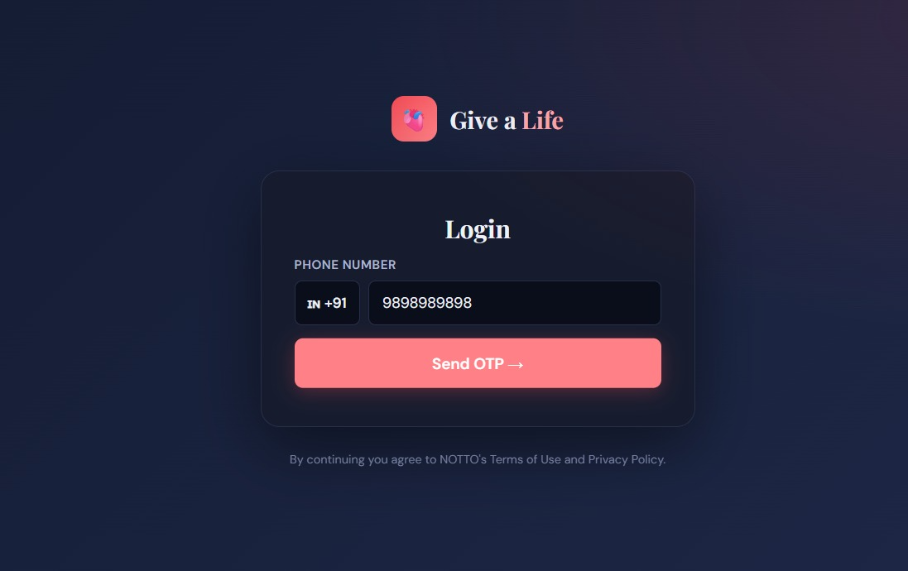

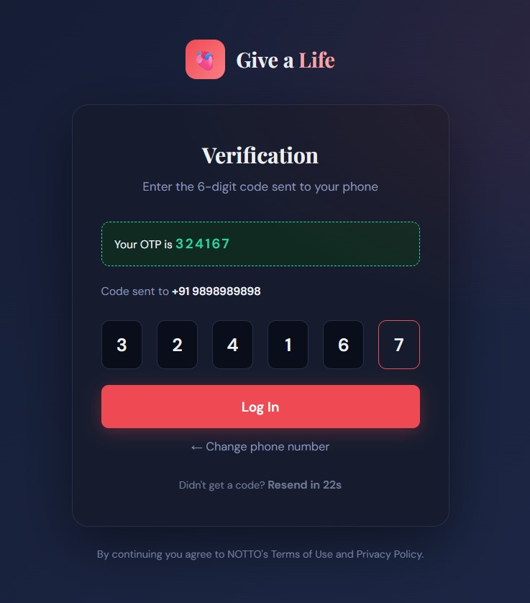

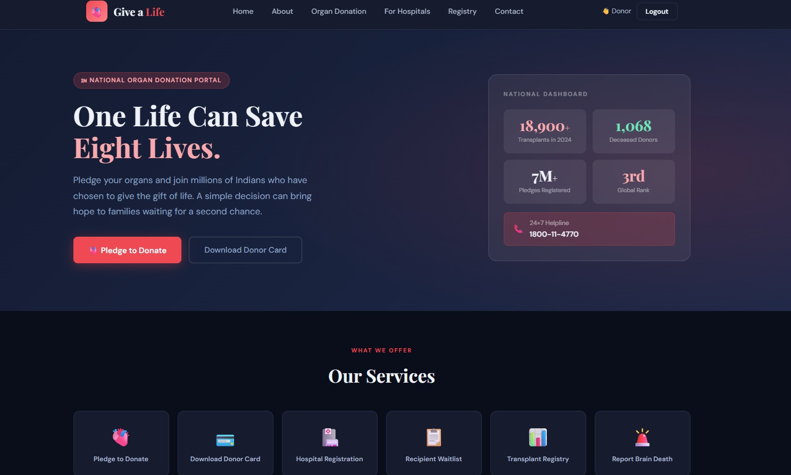

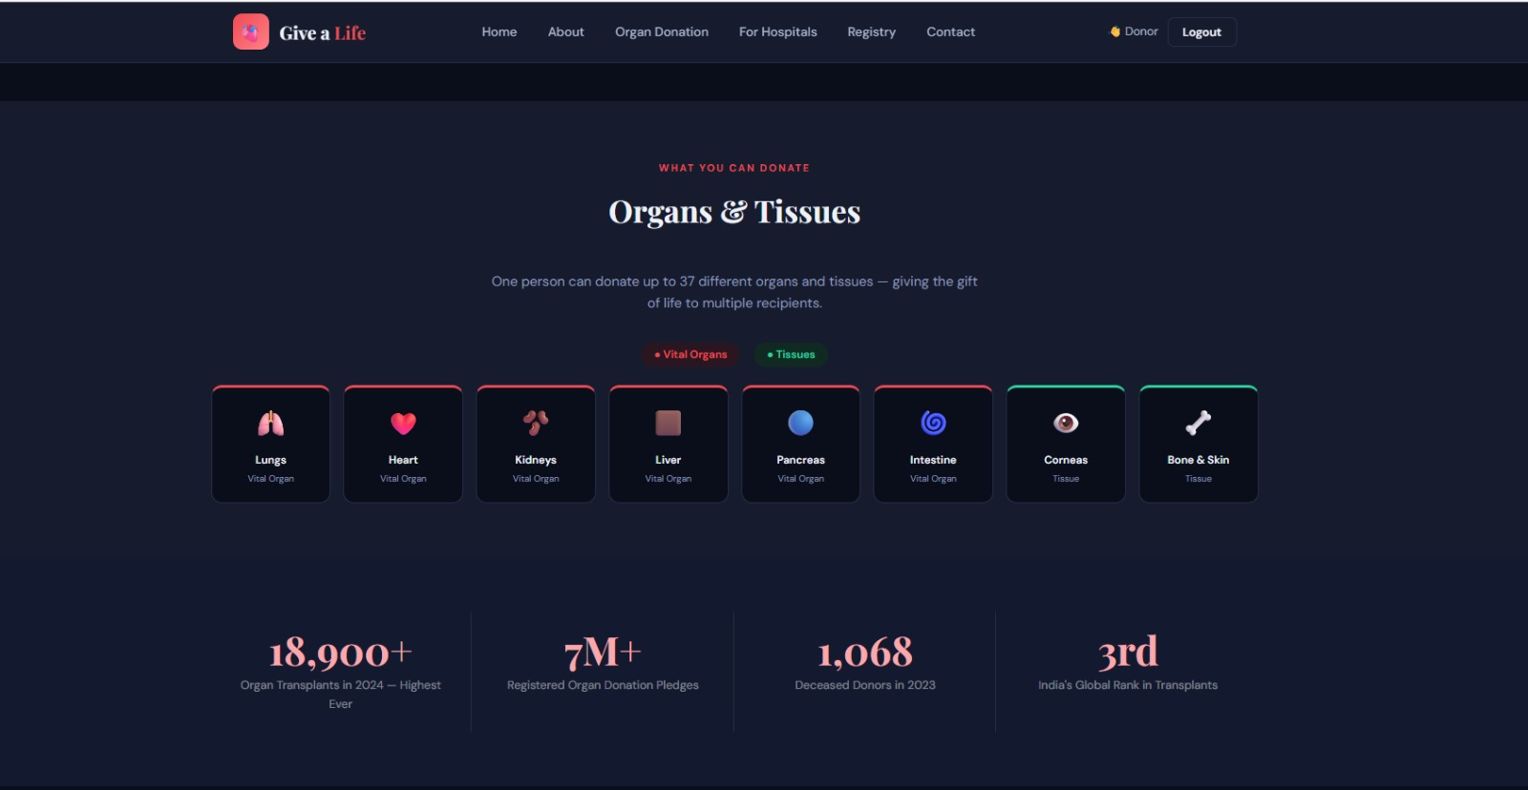

Sample code snippets

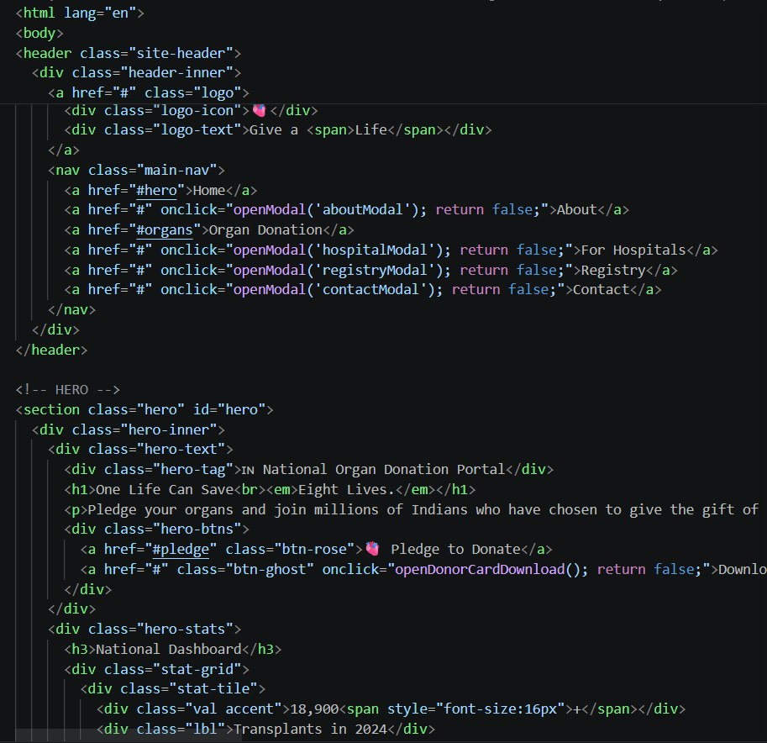

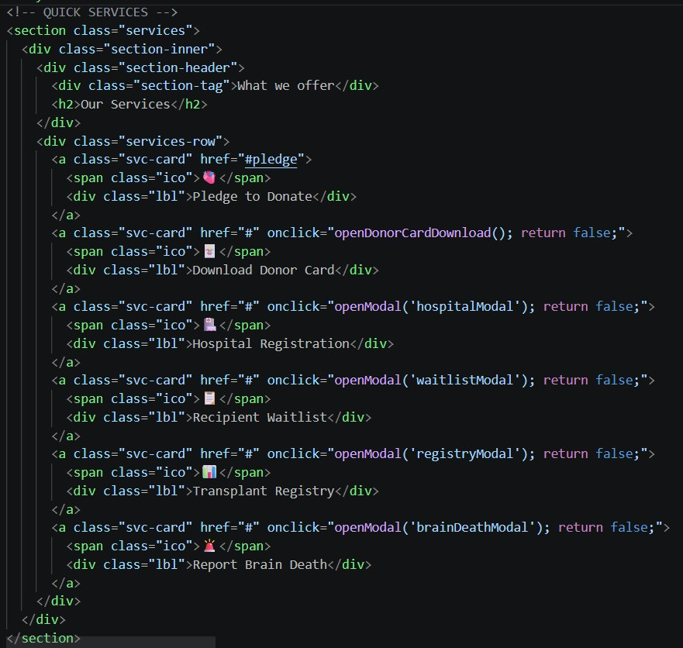

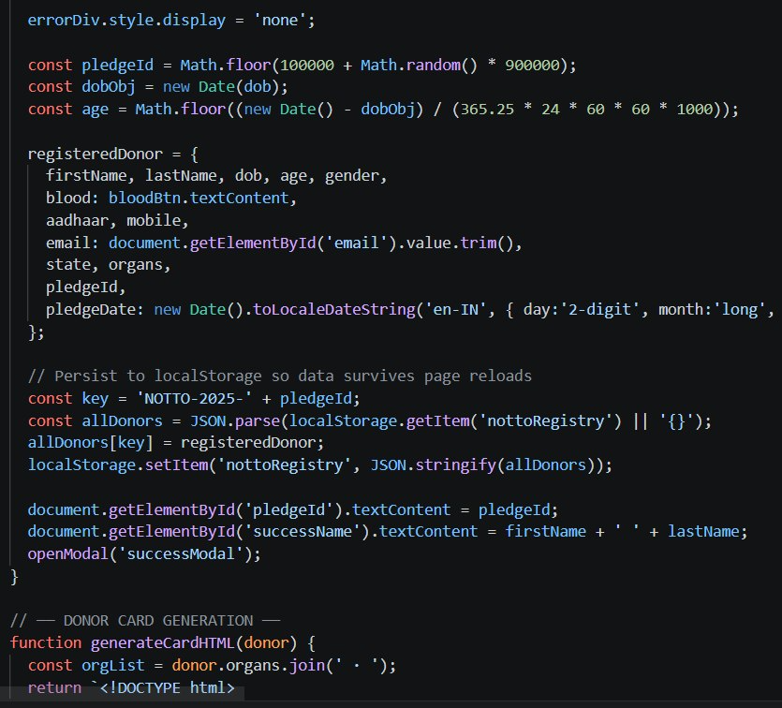

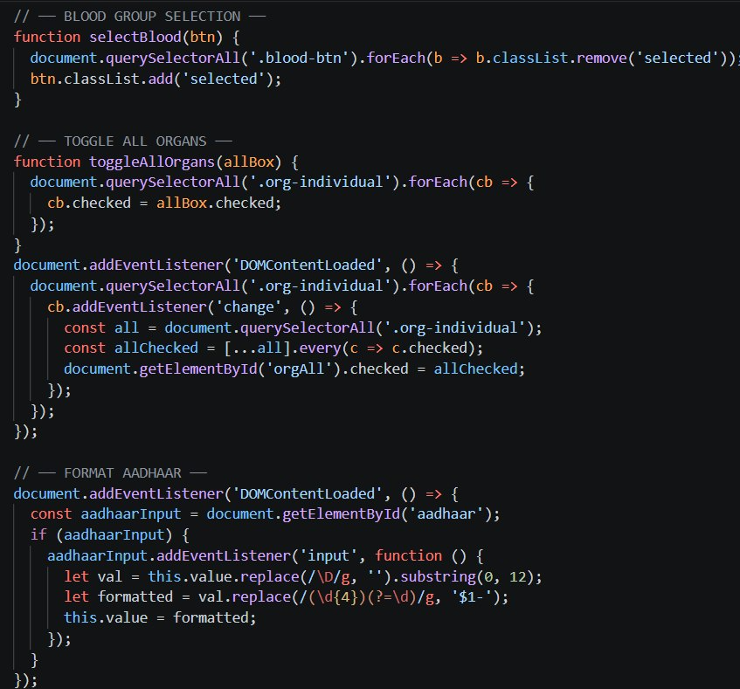
Installation/setup instructions

The GOglobe Integrated Tourism Platform is simple to install because it is built entirely using HTML, CSS, and JavaScript. It does not require any external frameworks or databases. The setup can be completed in just a few steps.

First, download or copy the complete GOglobe project folder to your local computer. If it is shared as a ZIP file, extract it using any standard extraction tool. Make sure all files especially index.html, style.css, and script.js (if included) are in the same folder.

Next, open the folder in a text editor like Visual Studio Code or Sublime Text to review or modify the code. To run the project, simply double-click on the index.html file or right-click and select “Open with Browser.” The website will open and function in any modern browser such as Google Chrome, Microsoft Edge, or Firefox.

No installations or dependencies are needed. The project is fully self-contained and works offline, making it ideal for classroom demonstrations and educational submissions.

User manual or guide

When you open the GOglobe platform, the homepage displays the main navigation bar with options like Login, Register, Destinations, and Travel Assistance. Users can begin by clicking the Login or Register buttons. A clean, half-page form will appear where users can enter their details to simulate login or registration.

Once logged in, users can explore Top Global Destinations, view beautiful travel images, and get information about each place. The Travel Assistance section offers quick options like medical help, hotel booking, and transportation support all designed for educational simulation.

